\ 

**Glamour Too Beauty Supply Requirements Specifications**

**PREPARED BY : KEJSI BUSHI**

**KLEA XHINA**

**GENTI HAVERI**

**Accepted by : Dr. Igli Hakrama**

Contents

Project Overview 3

Purpose and Scope of this Specification 3

Product/Service Description 3

Product Context 4

User Characteristics 4

Clients 4

Administrator 4

Employee 5

Requirements 5

Functional Requirements 5

Non – Functional Requirements 10

Product Requirements 10

Usability Requirements 10

Efficiency Requirements 11

Dependability Requirements 11

Organizational Requirements 12

Operational Requirements 12

Development Requirements 13

External Requirements 13

Regulatory Requirements 13

Ethical Requirements 13

USE CASE 22

Use Case 1 : Client 22

Use Case 2: Employee 23

USE CASE 4: GENERAL USE CASE 25

ACTIVITY DIAGRAMS 33

Activity Diagram 1 : Client 33

Activity Diagram 2: ADMIN Representative 38

STATE DIAGRAM 44

STATE - REGISTER 45

State – Update Profile 46

State – Open Recipe 46

State – Product Statistics 47

Collaboration Diagrams 55

AUTHENTICATION 55

Manage Employees 55

Product Information 56

Product Statistic 56

Sales Statistic 57

CLASS DIAGRAM 59

OBJECT DIAGRAM 60

OBJECT DIAGRAM 2: 61

ERD DIAGRAM 62

RELATIONAL SCHEMA 63

**Architecture** 64

Prototype 65

# Project Overview

A beauty store, also known as a beauty supply store or a cosmetics store, is a type of specialty retailer

that sells cosmetics, hair-care products, and/or beauty tools. Beauty supply stores sell a wide range of

beauty products, from makeup to sun care. Skin care, cosmetics and hair care products are the most

retailed products in this industry. Beauty, Cosmetics &amp; Fragrance Stores Industry comprises of stores

that predominantly retail cosmetics, perfumes, toiletries and personal grooming products et al.

Beauty treatments have advanced significantly in Albania in recent years, expanding the labor market

even further. However, problems with allergies or taking the wrong product occur frequently as a result

of the client’s lack of proper information. So we decided to create the Beaty Supply Store, where the

customer can not only find high-quality products, but also read reviews from previous customers, mark

an overview of a product in use, and see the product’s side effects.

## Purpose and Scope of this Specification

The main purpose of the Glamour Too Skin Care system would be to create a system that will help the business to grow more in the market. This system will offer to the clients the opportunity to get healthy skin and to the owner of the shop a successful business. The clients can choose to get a personal recipe to help with their skin concerns but also at the same time from the business perspective find the products that are more desirable. The owner of the shop will have detailed statistics regarding products, customers, and profits. Currently, the owner does not have a system that will calculate the number of products that have been sold and their current stock which consequentially leads to different mistakes.

This website would be very helpful to the customers since they can discover any allergies that they might not have been aware of, and find the products that will guarantee them a non-allergic reaction.

## Product/Service Description

Skin Care Software System is a software that helps the customers find the best face products depending on their concerns that might have. This software offers a full face guide to healthy skin. The client answering a few questions will get: -their recommended products (even if they have an allergic ingredient) -reviews from other customers -the place where he can find the products.

If a client login into the software, they will get the opportunity for their progress to be tracked. The user will have their personal diary where they can upload their pictures day to day, so they can see the changes better and help other customers with their reviews.

Reviews are another part of this software. Here the user will see: -reviews about one specified product -reviews about a type of allergy and how others have dealt with it -Photos

The user will have the opportunity to send a direct message to the page regarding a specific concern, or symptoms or even send feedback. In this way, the owner of the program has the opportunity to choose the more efficient products

Meanwhile, the owner will get statistics gathered from the clients. The most wanted products, profits, their stock, and allergy reaction from specific products are some of the information that will help the business to expand more and be more successful.

.

## Product Context

This product autonomous and self-sufficient. There are various supply stores because the beauty market

is large, but there is a lack of information, which can lead to serious problems from business to health.

Nonetheless, our product is much more manageable and informative, which distinguishes us from the

competition.

## User Characteristics

Beauty Supply involves three main users: the administrator, the employee and clients.

### Clients

Clients can come from a variety of age groups and backgrounds Guests can be users from various

backgrounds, but it can only be accessed by people over the age of 16. Our app will allow users of this

view to access the majority of the functionalities that registered users have access to. They will be able

to explore all of the app’s services. Clients are users can create an account in our app and are looking

forward to taking advantage of the services available in the app, the most important of which is booking

a specific skilled worker to provide some service. This user has the ability to have a personal account,

choose and buy products and leave notes about the used product.

### Administrator

The administrator is the head or the super admin. He has all the privileges. As a result, he or she will

assume administrative duties in our system. This means he or she will be in charge of every task that

occurs in Beauty Supply, as well as registering, updating, and deleting student information.

In the system, he or she will have the following capabilities.

He is able to generate real-time details on the customers and statistics provided by the data available

on the system.

1. He can read the reviews of the products.

2. He can also delete client and employers accounts

3. The administrator can view the stock of products.

4. The administrator can see the description and the ingredients for every product that is

registered.

## Employee

Workers are skilled individuals who opt to utilize the app in order to deliver services to other app users.

They may create profiles in the app and begin receiving orders from users after registering. They can

Glamour Too Beauty Supply Requirements Specification

also create alliances with one another to provide centralized services. Workers have access to the user-

driven bidding mechanism.

They can provide their workers and make specific service offerings while connecting with users using

this approach.

# Requirements

## Functional Requirements

|  |  |  |  |  |  |
| --- | --- | --- | --- | --- | --- |
| **Req#** | **Requirement** | **Comments** | **Priority** | **Date** | **SME Reviewed/Approved** |
| FR_1 | The system is implemented as a web application used by three functional user modules: users interested in a skincare routine, store employees, and administrators. | This will be the main platform of operation for all users. | High | 23/04/2022 |  |
| FR_2 | The administrator account must have all the privileges of the system. He will be able to generate real-time details on the customers and statistics provided by the data available on the system. | The admin account has full access to all functionalities and can access them at any time. | High | 23/04/2022 |  |
| FR_3 | The system must provide the administrator the store employee, with the right to register new customers. | This will help to add customers manually if they struggle to register on their own. | Medium | 23/04/2022 |  |
| FR_4 | The system must provide the customer with the option to write reviews on the website. | This will help other users to get more information regarding a product. | High | 23/04/2022 |  |
| FR_5 | The system must provide the customer the option to enter his personal details including any allergies that they might have. | This will help the users to choose products that they aren’t allergic to. | High | 23/04/2022 |  |
| FR_6 | The customer can register into the system with emails or their phone number. | This will help customers that don’t have an email the opportunity to register. | Medium | 23/04/2022 |  |
| FR_7 | The administrator, the store employee, and the customer can log in to the system with a username and a password. | This will make easier the process of logging in. | Medium | 23/04/2022 |  |
| FR_8 | The administrator can register new store employees by providing important information such as Name Surname, Date of Birth, etc. | Admin can register manually an employee. | High | 23/04/2022 |  |
| FR_9 | The administrator has the right to delete the employee account. | Admin can delete manually an employee. | High | 23/04/2022 |  |
| FR_10 | The administrator has the right to delete the customer account. | Admin can delete manually a customer account. | High | 23/04/2022 |  |
| FR_11 | The administrator can view private reviews regarding products. | Admin can see private reviews that the customer has written. | High | 23/04/2022 |  |
| FR_12 | The administrator can view the stock of products. | This will help the admin to get the needed products for their business. | High | 23/04/2022 |  |
| FR_13 | The administrator can generate statistics on a certain product. | This will help the admin to make better decisions in the future regarding the product. | High | 23/04/2022 |  |
| FR_14 | The administrator can generate statistics on the most wanted products. | This will help the admin to make decisions regarding that product. | High | 23/04/2022 |  |
| FR_15 | The administrator can generate statistics on the number of client registrations on a weekly/monthly/yearly basis. | This will help the admin to see the progress of the business. | Medium | 23/04/2022 |  |
| FR_16 | The administrator can generate statistics on the most common allergies the customers have. | This will be helpful so the admin can choose different products in the future. | High | 23/04/2022 |  |
| FR_17 | The administrator reports will have the option to export the data via an Excel file into the personal computer/ | Will help the admin account to access the data of the system at any time, even when offline. | Low | 23/04/2022 |  |
| FR_18 | The administrator can change only his own password in the Settings tab. | Admin will have the option to change their password. | High | 23/04/2022 |  |
| FR_19 | The administrator can send and receive a personal message to every user of the system. | This will help in the relationship between the client – and consultant. | High | 23/04/2022 |  |
| FR_20 | The administrator can generate statistics on the daily/weekly/monthly profits. | This will help the admin to see their profits. | High | 23/04/2022 |  |
| FR_21 | The administrator has the right to see only the employee’s personal details. | This will help the admin when business law is involved. | High | 23/04/2022 |  |
| FR_22 | The administrator can see the description and the ingredients for every product that is registered. | This will help the admin during conversations with the customers to recommend products that are for their skin concerns. | High | 23/04/2022 |  |
| FR_23 | The administrator can receive a notification when a product is near out of the stock. | This will help the admin to decide if he/she wants to restock a product or not. | High | 23/04/2022 |  |
| FR_24 | The employee can view his/her own profile and make necessary edits and/or updates on the personal information he/she provides for the system | The employee is responsible for updating his/her own profile information with correct data. | Medium | 23/04/2022 |  |
| FR_25 | The employee can send and receive personal messages to the other employee or the customer. | This will help in the relationship between the client – and consultant or employee -employee. | Medium | 23/04/2022 |  |
| FR_26 | The employee can see product descriptions and/or ingredients. | This will help the employee to give recommendations. | High | 23/04/2022 |  |
| FR_27 | The employee can see customer reviews for a product. | This will help the employee to give proper recommendations. | High | 23/04/2022 |  |
| FR_28 | The employee can change only his password in the Settings section. | Employees will have the option to change their passwords. | High | 23/04/2022 |  |
| FR_29 | The employee can see product stock. | This will help the employees to know more about the products that are in the store. | Medium | 23/04/2022 |  |
| FR_30 | The employee can see allergic symptoms a product cause. | This will help the employee to help other customers with the same symptoms. | High | 23/04/2022 |  |
| FR_31 | The employee can deactivate his/her account. | If for any reason employee is not working at the business, he/she should delete his account. | High | 23/04/2022 |  |
| FR_32 | The employee can view the upcoming products. | This will help the employee to be more informed regarding the products. | Medium | 23/04/2022 |  |
| FR_33 | The employee can receive notifications when the product stock is low. | Employees will be informed regarding a specified product. | Medium | 23/04/2022 |  |
| FR_34 | The employee can export statistics to an excel form. | This feature will help the employee account to access the permitted data at any time, even offline. | Low | 23/04/2022 |  |
| FR_35 | The employee can see the most wanted product regarding a skincare concern. | This will be important to create a deeper understanding of the products and the benefits of their use. | High | 23/04/2022 |  |
| FR_36 | The customer can view his/her profile and make necessary edits and/or updates on the personal information he/she provides for the system. | The customer is responsible for updating his/her own profile information with correct data. | Medium | 23/04/2022 |  |
| FR_37 | The customer can take a quiz to find out the most compatible products regarding their concerns. | This will help the customer to get the right products regarding their skin concerns. | High | 23/04/2022 |  |
| FR_38 | The customer can download their recipe or save it on their personal account. | This extra feature will help the customer account to have the recipe at any time, even when offline. | Low | 23/04/2022 |  |
| FR_39 | The customer can upload daily/ weekly/ monthly updates after using the products | Customer can see their progress and decide if they want to continue using a specific product or not. | Low | 23/04/2022 |  |
| FR_40 | The customer can send and receive messages to the employee or the automatic system. | This will help the customers with a problem they might have. | High | 23/04/2022 |  |
| FR_41 | The customer can write a public or private review regarding a product. | Customers decide if they want that their review to be seen by everyone or just employee/admin. | Medium | 23/04/2022 |  |
| FR_42 | The customer can change only his own password. | The customer has the right to change his password. | Medium | 23/04/2022 |  |
| FR_43 | The customer can receive notifications when a product he wants has arrived. | If in any case, they want a product that is out of stock, when the product has arrived, they will get a notification. | Medium | 23/04/2022 |  |
| FR_44 | The customer can see some of the most common allergies in products. | This will help the customer to see if a product that he/she is interested in has an ingredient that can cause an allergic reaction. | Medium | 23/04/2022 |  |
| FR_45 | The customer can deactivate their account anytime. | If the customer doesn’t want to use the website anymore they can deactivate their account. | Medium | 23/04/2022 |  |
| FR_46 | The customer can download the bill after making a purchase. | This will help the customer to have a copy of its data even offline | Medium | 3/05/2022 |  |

# Non – Functional Requirements

## Product Requirements

### Usability Requirements

#### Efficiency

* The website would be very efficient, meaning that the user will get what their want quickly and with few or no user errors.
* Every element on the website would be understandable and clearly labeled.

#### Effectiveness

* The website would be effective, meaning that it will be simple, and easy to learn and understand.
* Every option that is on the website will be explained in a manual to eliminate ambiguities.
* Every error message would be clear and understandable for each user.
* The language of use would be simple.

#### Error Tolerance

* The website would have a low error rate, meaning that the user can easily recover from an error.
* The website will have the option “redo” so the users can have the opportunity to reset what they might have done.
* Every option would be clear and distinct.

#### Memorability

* The website would be memorable, meaning that the user will not have difficulties using it after returning after a period of time.
* Every icon will be labelled which means the user will not be confused.

### Efficiency Requirements

#### Performance Requirements

Glamour Too Beauty Supply is a webpage that works only with an internet connection, which means that having a stable internet connection is one of the main points to getting all the desired facilities that the user might want.

The number of users that have opened the webpage at the same time, the server hardware, and the storage space determine the system performance.

The user's performance requirement is that the web application should be created as lightweight software that can run on nearly any platform.

#### Space Requirements

When the system is first turned on, the expected number of concurrent users should be at least 200-

250. The system should be able to handle 600 users at once. In addition, the system’;s database should

be able to manage at least a thousand users at any given time.

### Dependability Requirements

#### Security

Since the system is connected to the internet it has a higher risk of being attacked. That means that the access is granted to authorized users. Employees will have more access than the customers but less than the main admin who has the right to access the database.

The system will auto-generate a strong password for the user before registering.

#### Availability

The application would be available 24/7, meanwhile communicating directly with the manager or the employee would be available from 9 AM till 10 PM.

The application can be accessed in different web browsers from any country in the world.

The application is available, only if the users have internet access.

#### Reliability

The application is expected to have a storage of at least 300GB SSD which will support the growing number of the users since the number of clients in the store is about 3300.

#### Maintenance

To ensure that all requests are executed in real time, the web application will be updated on a regular

basis.

The server should direct the user to an error page that displays the Error 404 standard response code in

the event of a system crash.

During a crash, the system should be restarted as quickly as feasible by re-configuring the server.

Integrity

All of the data is confidential and only the Beauty Supply offices have access to it. Users must be able to

communicate with other modules using an open and secure communication platform provided by the

web application. The administrator account is responsible for updating the database and adding new

user information. Before browsing their own accounts, individuals must first provide personal

credentials and be validated.

## Organizational Requirements

### Operational Requirements

Glamour Too System is a web-based platform that eases the communication between clients and the store owner. The main operations that will be available to the customers account are as follows:

* Client Personal information
* Getting their personal recipe
* Writing to the store employee/owner
* Write reviews.
* See the products the store offers

Store Employee will have all the functionalities that the customer have, but also have the opportunity to see the stock of the products or the upcoming products. Their operations are as follows:

* Replying to the customer questions
* Generating statistics for the most wanted products, the most common allergies.

The admin account has all functionalities of the store employee and clients but he can also delete employee/clients account, see sales during a specific period of time, make changes in the product price, changing the stock data.

### Development Requirements

1. Client- Side Programming (Front- End)

Client Side Programming includes everything that the user will see on the screen. Technologies that are going to be used are :

* Hypertext Markup Language 5 (HTML5), Cascading Style Sheets(CSS)
* JavaScript will be used to make web pages interactive, validating the data etc.

1. Server-Side Programming (Back-end)

* Programming language : PHP
* To store the data : MySQL

## External Requirements

### Regulatory Requirements

The Beauty Supply Store will be located at bsupplystore@gmail.com , which is the primary domain of

Beaty Supply. The website shall implement privacy rules in accordance with the terms of Law No. 9887,

dated 10.03.2008;On the Protection of Personal Data” and similar sub-legal acts. The Privacy Policy

explains the types of information that will be gathered and how it will be used. IP addresses of users to

this web application, like those of most institutions and entities on the Internet, are utilized to diagnose

problems with Beauty Supply Store’s main server and to administer by determining how the site is being

used. IP addresses are not linked to any information that can be used to identify a person. That is to say

that users’ sessions will be logged, but their identities will remain anonymous.

### Ethical Requirements

Users’ personally identifiable information, such as email addresses, names, surnames, phone numbers,

and other information, will never be sold or traded to other higher education institutions, businesses, or

non-profit organizations.

The website will also share personally identifiable information about users of this web application to

third parties if one or more of the following conditions are met:

Current legislation, court orders, or an act of a public or regulatory authority have asked or permitted

the administrator to divulge the information.

The administrator shares the information in order to preserve property rights, the security of Epoka

University’s facilities, its personnel and students, and other individuals.

Security Requirements

The personal information of every user of this system will be protected by the relevant regulations and

legislative standards that are already in place on Albanian soil. In Albania, the Commission for Personal

Data Protection issues licenses to institutions, organizations, and/or corporations that allow them to

handle personal and sensitive information about information system users. Because the website will

operate under the Beaty Supply Store website domain, it will be covered by this rule. According to

statute No.9887, dated 10.03.2008, as amended by law No.48/2012, “On the Protection of Personal

Data,” each user’s personal information must be kept secret and available only to the specified actors.

As a result, hashed passwords issued Beauty Store’s clients via the account given will already protect

their information.

Domain Requirements

Our system’s domain needs will be based on an Beauty Store environment. The major goal of this

system is to provide a communication platform for clients and employees. Each client will have a unique

profile with which they will be able to carry out a specific set of tasks. In our system, there are only three

types of users: Administrator, Employee and Client. This application was created for a single Beauty

Store to utilize in order to personalize the client’s budget and wishes.

User Scenarios1. Web App Scenario – Successful Login

1.1 Client

a. The user clicks the Login with Email button.

b. If the credentials are correct from the mail Glamour Too Beauty Supply database,

the user is logged in.

c. The user will be taken to his or her own account’s dashboard.

1.2 Administrator

a. The user is prompted to provide his or her username.

b. The user is prompted to provide his or her password.

c. The user will be logged in if the credentials from the database are correct.

d. The user will be taken to the dashboard after being redirected.

Glamour Too Beauty Supply Requirements Specification

1.3 Employee

a. The user is prompted to provide his or her username.

b. The user is prompted to provide his or her password.

c. The user will be logged in if the credentials from the database are correct.

d. The user will be taken to the dashboard after being redirected.

2 Web App Scenario – Failed Login

2.1 Client

a. The user selects Login with Email from the drop-down menu.

b. The user is not logged in if the credentials from the Glamour Too Beauty Supply mail

database are incorrect.

c. An error notice will be displayed to the user.

d. The user will remain on the Login page.

2.2 Administrator

a. The user must enter his or her username.

b. The user must enter his or her password.

c. The user is not logged in if the database credentials are incorrect.

d. An error notice will be displayed to the user.

e. The user will remain on the Login page.

2.3 Employee

a. The user must enter his or her username.

b. The user must enter his or her password.

c. The user is not logged in if the database credentials are incorrect.

d. An error notice will be displayed to the user.

e. The user will remain on the Login page.

3. Client– Update Profile

3.1 Update Personal Details

a. The user is logged in the webpage.

Glamour Too Beauty Supply Requirements Specification

b. Then the user selects “Product” from the Dashboard’s sidebar.

c. The user can click on Review and adding a personal opinion or experience to the product

chosen and then choose to post it publicly or privately.

d. The user can edit personal health information like allergies by clicking the Edit button.

e. The customer can see some of the most common allergies in products

f. The customer can take a quiz to find out the most compatible products regarding their

concerns.

g. The customer can download their recipe or save it on their personal account.

3.2 Update Profile Picture

a. The user logs into the Glamour.

b. The user selects “Profile” from the Dashboard’s sidebar.

c. The user can select Edit Picture from the drop-down menu.

d. To pick a file from the PC, a dialog window is opened.

e. The user chooses a file to replace the image

f.The user presses the Done button

4. Administrator – Update profile

4.1 Update Profile Picture

a. The user logs into the Glamour.

b. The user selects “Profile” from the Dashboard’s sidebar.

c. The user can select Edit Picture from the drop-down menu.

d. To pick a file from the PC, a dialog window is opened.

e. The user chooses a file to replace the image

f.The user presses the Done button

5. Administrator – Register

5.1 Administrator – Register: Add Client

a. The administrator user is logged in.

b. The user selects “Register” from the Dashboard’s sidebar.

Glamour Too Beauty Supply Requirements Specification

c. Under Register, the user picks the “Add Client” sub-button.

d. The user is presented with an empty registration form to fill out in order to register the

client’s information.

e. The user completes the form by filling in the blank fields with pertinent information.

f. When the user clicks done, the new client is saved and added to the database.

g. To clear the form fields, the user clicks the reset button.

5.2 Administrator – Register: Add Employee

a. The administrator user is logged in.

b. The user selects “Register” from the Dashboard’s sidebar.

c. Under Register, the user picks the “Add Employee” sub-button.

d. The user is presented with an empty registration form to fill out in order to register the

employee’s information.

e. The user completes the form by filling in the blank fields with pertinent information.

f. When the user clicks done, the new employee is saved and added to the database.

g. To clear the form fields, the user clicks the reset button.

6. Administrator – View

6.1 Administrator – View Client

a. The administrator user is logged in.

b. The user selects the View option from the Dashboard’s sidebar.

c. Under the View Button, the user selects the View Clients sub-button.

d. The user is presented with a tabular form of clients data that includes all of their

information.

e. If no clients records are found, a message stating “There are no items” will be displayed.

6.2 Administrator – View Employee

a. The administrator user is logged in.

b. The user selects the View option from the Dashboard’s sidebar.

c. Under the View Button, the user selects the View Employee sub-button.

d. The user is presented with a tabular form of employee data that includes all of their

information.

e. If no Employee records are found, a message stating “There are no items” will be

displayed.

7 Administrator – View Products

a. The administrator user is logged in.

b. The user selects the View option from the Dashboard’s sidebar.

c. Under the View Button, the user selects the View Reviews sub-button.

d. The user is presented with a tabular form of clients reviews.

e. The user can see the description and the ingredients for every product that is registered

in the “Registered Products” button

f. When a product is near out of the stock, the user can receive a notification.

8 Administrator – Generate Statistics

a. The Administrator user is logged in.

b. The user selects Statistics from the Dashboard’s sidebar.

c. The user is presented with pie charts and histograms based on data from products.

d. The user can make a decision based on the statistics provided.

e. The user can generate statistics on the most common allergies the customers have.

The user can export the data in Excel format to their local PC by clicking the Export

buttonWeb App Scenario - S

9 Employer- Update Profile

9.1 Update Personal Details

a. The user is logged in the webpage.

b. Then the user selects “Product” from the Dashboard’s sidebar.

c. The user can click on Review and adding a personal opinion or experience to the product

chosen and then choose to post it publicly or privately.

d. The user can edit personal health information like allergies by clicking the Edit button.

e. The customer can see some of the most common allergies in products

f. The customer can take a quiz to find out the most compatible products regarding their

concerns.

g. The customer can download their recipe or save it on their personal account.

Glamour Too Beauty Supply Requirements Specification

9.2 Update Profile Picture

a. The user logs into the Glamour.

b. The user selects “Profile” from the Dashboard’s sidebar.

c. The user can select Edit Picture from the drop-down menu.

d. To pick a file from the PC, a dialog window is opened.

e. The user chooses a file to replace the image

f.The user presses the Done button

10 Employee offers service

a. The employee double-checks that he or she is logged into the application.

b. The employee logs into his account and selects Services Offered from the drop-down

menu.

c. He clicks the “+” button in the top right corner of the section.

d. In his profile, the Service is updated and added to the general Services area.

11 Employee views “Clients reviews”

a. The user logs into his account

b. The user clicks the “View Reviews” button on the Dashboard’s left side.

c. The user is displayed in two tabs client reviews and product notes

d. If there are reviews, a notification stating “There are no items listed”

appears.

e. To examine the details of any posting, the user can click on the View More

link.

f. The user is taken to a full job information page.

g. The user can erase the post by clicking the trash symbol button on top of it.

h. The user will be taken to the page “View Reviews”

12 Employee– Generate Statistics

a. The employee user is logged in.

b. The user selects Statistics from the Dashboard’s sidebar.

c. The user is presented with pie charts and histograms based on data from products.

d. The user can make a decision based on the statistics provided.

e. The user can generate statistics on the most wanted product from clients.

The user can export the data in Excel format to their local PC by clicking the Export button

DIAGRAMS

## USE CASE

### Use Case 1 : Client

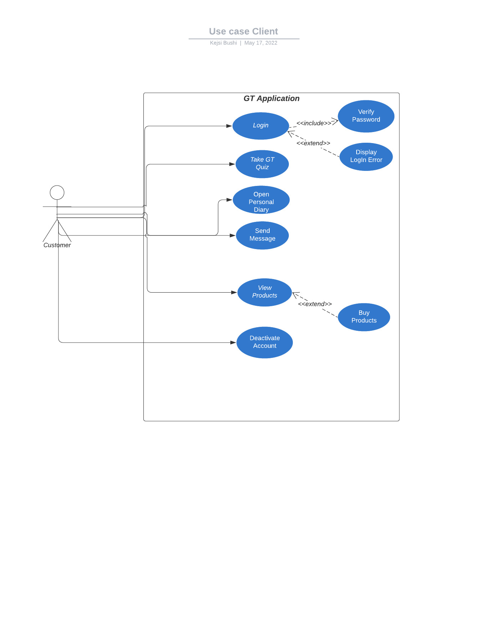

### Use Case 2: Employee

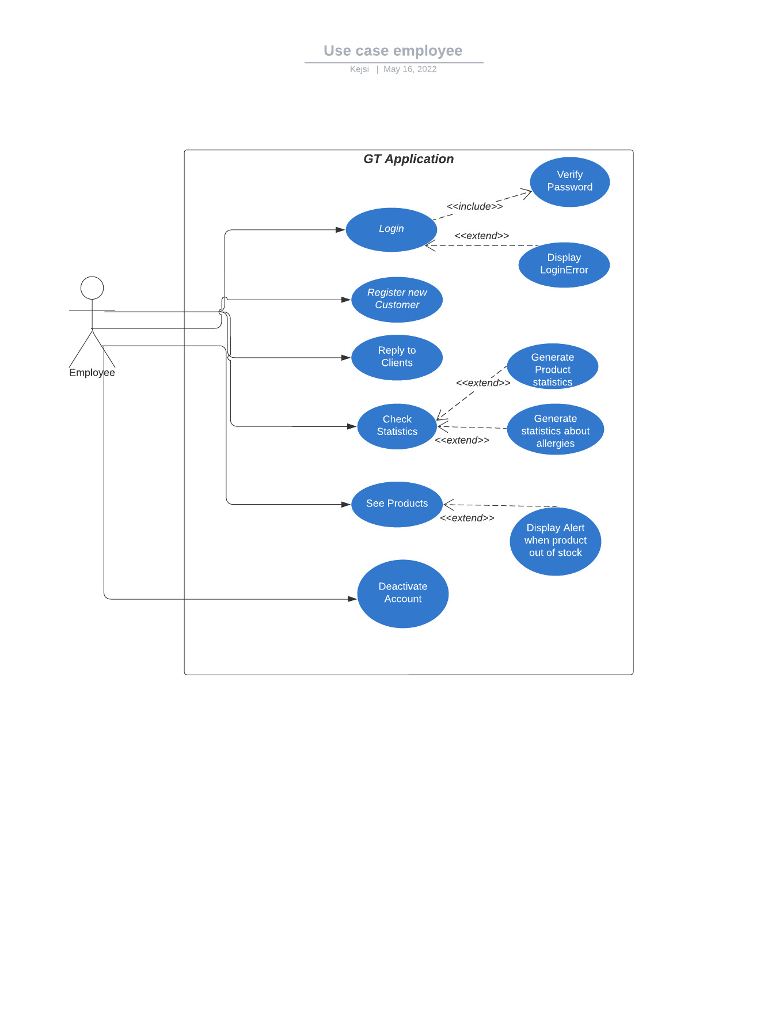

USE CASE 3: ADMINISTRATOR

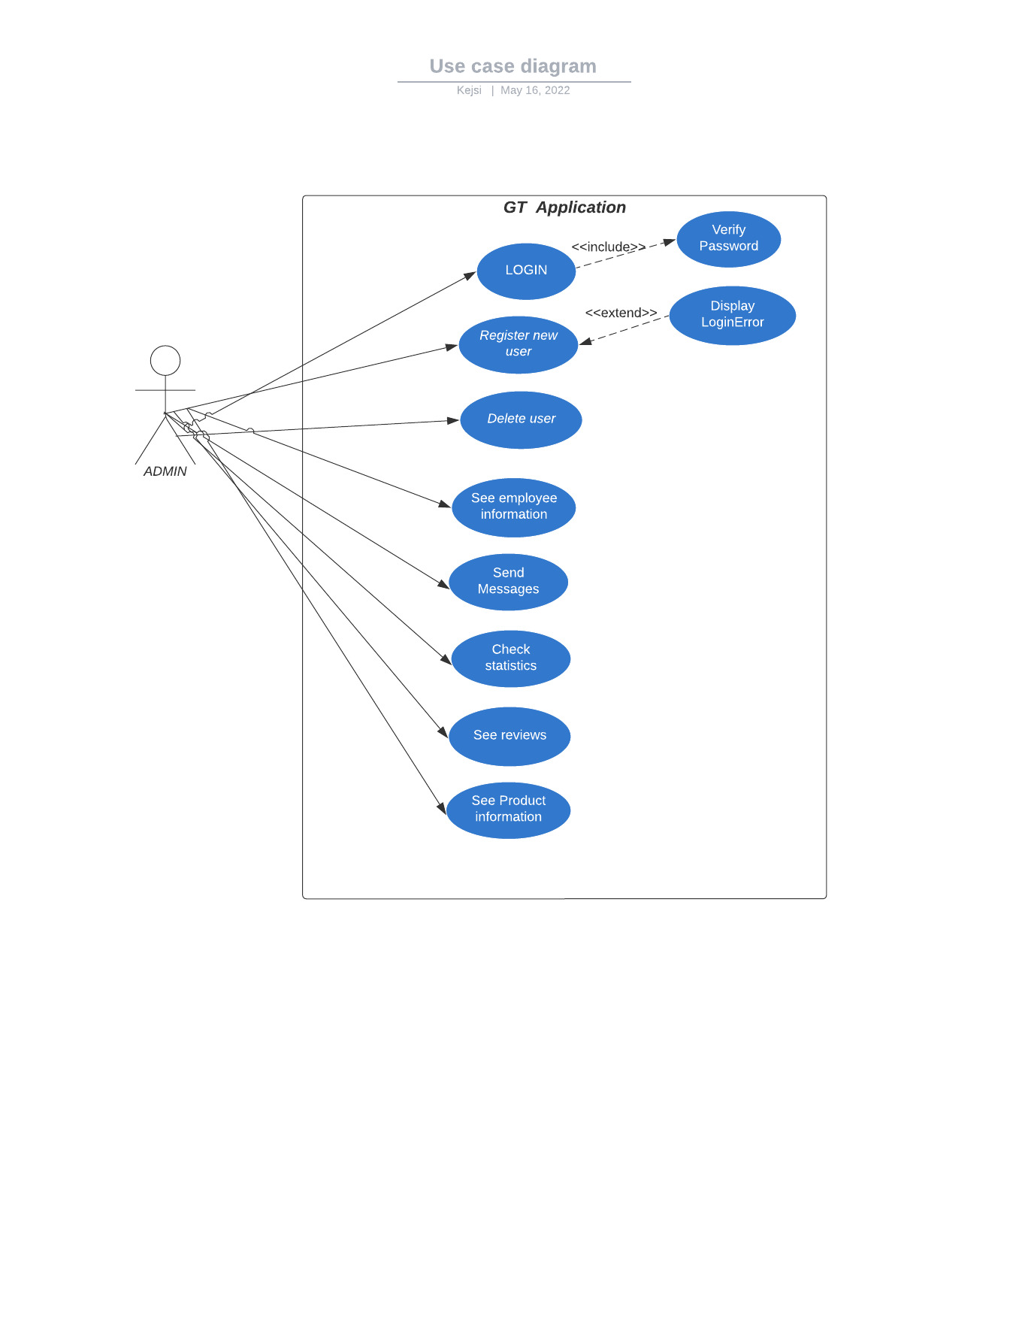

### USE CASE 4: GENERAL USE CASE

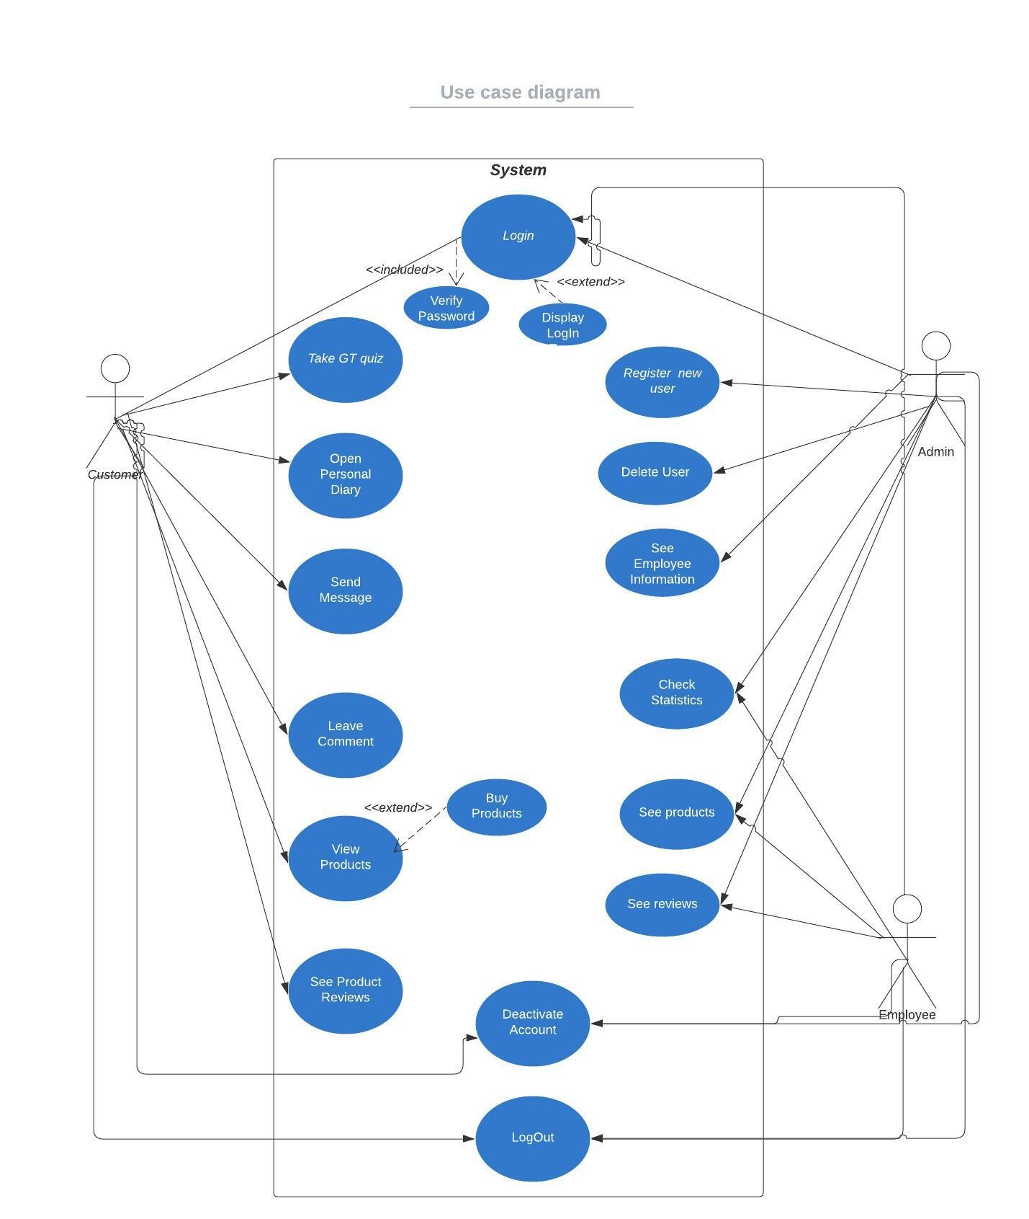

USE CASE EXTENDED

|  |  |
| --- | --- |
| Use Case (UC_1.1): | Login |
| Scope | Beauty Supply System |
| Level | User Level |
| Intention Context | Any client who wants to be part of this website needs an account so he can login. |
| Minimum Guarantees | The password is not correct and login error is displayed |
| Success Guarantees | The clients gives its email and its password, click login and he has now its account opened |
| Primary Actor | Beauty Supply Client |
| Stakeholder Interest | To have as many client accounts as possible |
| Precondition | Have an email and password |

|  |  |
| --- | --- |
| Use Case (UC_1.2): | Take GT Quiz |
| Scope | Beauty Supply System |
| Level | User Level |
| Intention Context | The client takes this quiz so he choose products which wont cause them health issues like allergies. |
| Minimum Guarantees | Application guaranteed but not approved by employer |
| Success Guarantees | The client fills the quiz click submit and then continues on choosing the product |
| Primary Actor | Beauty Supply Client |
| Stakeholder Interest | To know client health issues (if there are) |
| Precondition | Client is logged in system |

|  |  |
| --- | --- |
| Use Case (UC_1.3): | Open Personal Diary |
| Scope | Beauty Supply System |
| Level | User Level |
| Intention Context | Give everyday results from the product chosen to see its effects. |
| Minimum Guarantees | User has given a response, but it isn’t saved to the database. |
| Success Guarantees | User has its response and photos saved and published |
| Primary Actor | Beauty Supply Client |
| Stakeholder Interest | The organizer of the event can keep track automatically of the progress |
| Precondition | At least one photo of the progress is posted |

|  |  |
| --- | --- |
| Use Case (UC_1.4): | Send Message |
| Scope | Beauty Supply System |
| Level | User Level |
| Intention Context | User sends message to employer |
| Minimum Guarantees | User send the message but wasn’t received by the employer |
| Success Guarantees | User has its response and photos saved and published |
| Primary Actor | Beauty Supply Client |
| Stakeholder Interest | The organizer of the event can keep track automatically of the progress |
| Precondition | At least one photo of the progress is posted |

|  |  |
| --- | --- |
| Use Case (UC_1.3): | View Product |
| Scope | Beauty Supply System |
| Level | User Level |
| Intention Context | The user can see each product from the specifications he has given |
| Minimum Guarantees | User has searched for a product but it isn’t registered |
| Success Guarantees | User has found the product wanted so he buys it |
| Primary Actor | Beauty Supply Client |
| Stakeholder Interest | The administrator received a message for the product wanted by the client |
| Precondition | Client’s location is given |

|  |  |
| --- | --- |
| Use Case (UC_1.3): | Deactivate Account |
| Scope | Beauty Supply System |
| Level | User Level |
| Intention Context | If a client doesn’t want to own his account anymore, he can deactivate it |
| Minimum Guarantees | User has given the request but the system has crashed |
| Success Guarantees | User has its response and deactivates account successfully |
| Primary Actor | Beauty Supply Client |
| Stakeholder Interest | The organizer of the event can keep track automatically of the progress |
| Precondition | Previous email and password |

|  |  |
| --- | --- |
| Use Case (UC_2.1): | Login |
| Scope | Beauty Supply System |
| Level | User Level |
| Intention Context | Any user who wants to be part of this website needs an account so he can login. |
| Minimum Guarantees | The password is not correct and login error is displayed |
| Success Guarantees | The user gives its email and its password, click login and he has now its account opened |
| Primary Actor | Beauty Supply Client |
| Stakeholder Interest | To have as many users accounts as possible |
| Precondition | Have an email and password |

|  |  |
| --- | --- |
| Use Case (UC_2.1): | Register |
| Scope | Beauty Supply System |
| Level | User Level |
| Intention Context | To be able to register a new client in the system and update all the  information on the database. |
| Minimum Guarantees | The system shows the filling form for the client |
| Success Guarantees | The client data are successfully updated into the database and the client is entered in the system |
| Primary Actor | Beauty Supply Employee |
| Stakeholder Interest | To be able to add a new client with the correct information |
| Precondition | The user should be logged in the system and enter all the required  information |

|  |  |
| --- | --- |
| Use Case (UC_2.1): | Reply to Clients |
| Scope | Beauty Supply System |
| Level | User Level |
| Intention Context | To be able to read and reply to all clients comments. |
| Minimum Guarantees | The system shows the filling form for the employee |
| Success Guarantees | The employee responds to questions asked by clients |
| Primary Actor | Beauty Supply Employee |
| Stakeholder Interest | To have happy and informed clients |
| Precondition | The user should be logged in the system and enter all the required  information |

|  |  |
| --- | --- |
| Use Case (UC_2.1): | Check Statistics |
| Scope | Beauty Supply System |
| Level | User Level |
| Intention Context | To be able to view the clients statistics based on their review. |
| Minimum Guarantees | There are clients data entered in the database which will be used to generate statistics |
| Success Guarantees | The user can view and export meaningful statistics based on the client data |
| Primary Actor | Beauty Supply Employee |
| Stakeholder Interest | To make meaningful decisions based on the statistics provided in the blog |
| Precondition | The user must be logged in and there should be registered clients in the  database |

|  |  |
| --- | --- |
| Use Case (UC_1.3): | Deactivate Account |
| Scope | Beauty Supply System |
| Level | User Level |
| Intention Context | If employee doesn’t want to own his account anymore, he can deactivate it |
| Minimum Guarantees | User has given the request but the system has crashed |
| Success Guarantees | User has its response and deactivates account successfully |
| Primary Actor | Beauty Supply Employee |
| Stakeholder Interest | The organizer of the event can keep track automatically of the progress |
| Precondition | Previous email and password |

|  |  |
| --- | --- |
| Use Case (UC_1.1): | Login |
| Scope | Beauty Supply System |
| Level | User Level |
| Intention Context | Any user who wants to be part of this website needs an account so he can login. |
| Minimum Guarantees | The password is not correct and login error is displayed |
| Success Guarantees | The user gives its email and its password, click login and he has now its account opened |
| Primary Actor | Beauty Supply Administrator |
| Stakeholder Interest | Keep the account safe |
| Precondition | Have an email and password |

|  |  |
| --- | --- |
| Use Case (UC_2.1): | Register |
| Scope | Beauty Supply System |
| Level | User Level |
| Intention Context | To be able to register a new user in the system and update all the  information on the database. |
| Minimum Guarantees | The system shows the filling form for the user |
| Success Guarantees | The user data are successfully updated into the database and the user is entered in the system |
| Primary Actor | Beauty Supply Employee |
| Stakeholder Interest | To be able to add a new client with the correct information |
| Precondition | The user should be logged in the system and enter all the required  information |

|  |  |
| --- | --- |
| Use Case (UC_1.1): | Login |
| Scope | Beauty Supply System |
| Level | User Level |
| Intention Context | The main goal is to remove from the system any entry which is incorrect or  mistakenly entered in the system |
| Minimum Guarantees | The user performs the delete operation and provides information on the data that should be removed from the system |
| Success Guarantees | The user enters correctly the query that must be deleted and the system after removes it from the database and the system, provides a success message to the user. |
| Primary Actor | Beauty Supply Administrator |
| Stakeholder Interest | To have removed any data that is no longer sufficient for the system. |
| Precondition | The user must be logged in the system and he/she should have opened the  view tables in order to compete the process. |

|  |  |
| --- | --- |
| Use Case (UC_1.3): | View Employer Information |
| Scope | Beauty Supply System |
| Level | User Level |
| Intention Context | admin can see a list with clients/employee in order to have a representation of the database saved information |
| Minimum Guarantees | A list of users is shown |
| Success Guarantees | After clicking view user, a table with the user saved to the database is shown to the user |
| Primary Actor | Beauty Supply Administrator |
| Stakeholder Interest | The user is able to view details to the users’ information and make any changes if wanted |
| Precondition | At least one user must have been registered in the system |

|  |  |
| --- | --- |
| Use Case (UC_1.3): | Send Messages |
| Scope | Beauty Supply System |
| Level | User Level |
| Intention Context | The user is notified with the latest news from the website |
| Minimum Guarantees | There is a notification button in the page, but it doesn’t show the necessary information |
| Success Guarantees | Any user can receive messages and/or notifications that will facilitate their  usage |
| Primary Actor | Beauty Supply Administrator |
| Stakeholder Interest | There does exist an interaction with users, which will make the website more flexible |
| Precondition | The user is logged in the system |

|  |  |
| --- | --- |
| Use Case (UC_2.1): | Check Statistics |
| Scope | Beauty Supply System |
| Level | User Level |
| Intention Context | To be able to view the employee/clients statistics based on their review. |
| Minimum Guarantees | There are employee/clients data entered in the database which will be used to generate statistics |
| Success Guarantees | The user can view and export meaningful statistics based on the employee/client data |
| Primary Actor | Beauty Supply Administrator |
| Stakeholder Interest | To make meaningful decisions based on the statistics provided in the blog |
| Precondition | The user must be logged in and there should be registered employee/clients in the database |

|  |  |
| --- | --- |
| Use Case (UC_2.1): | See Reviews |
| Scope | Beauty Supply System |
| Level | User Level |
| Intention Context | Since administrator would be the admin of the system, he/she will have to control the operations done in the system in order to maintain the review system efficiently |
| Minimum Guarantees | The review page is shown to administrator |
| Success Guarantees | administrator can check in real time the latest review post done by clients |
| Primary Actor | Beauty Supply Administrator |
| Stakeholder Interest | To have an efficient and effective use of system without  malicious problems |
| Precondition | clients have posted at least one post in the blog |

DATA FLOW DIAGRAM

1. Level 0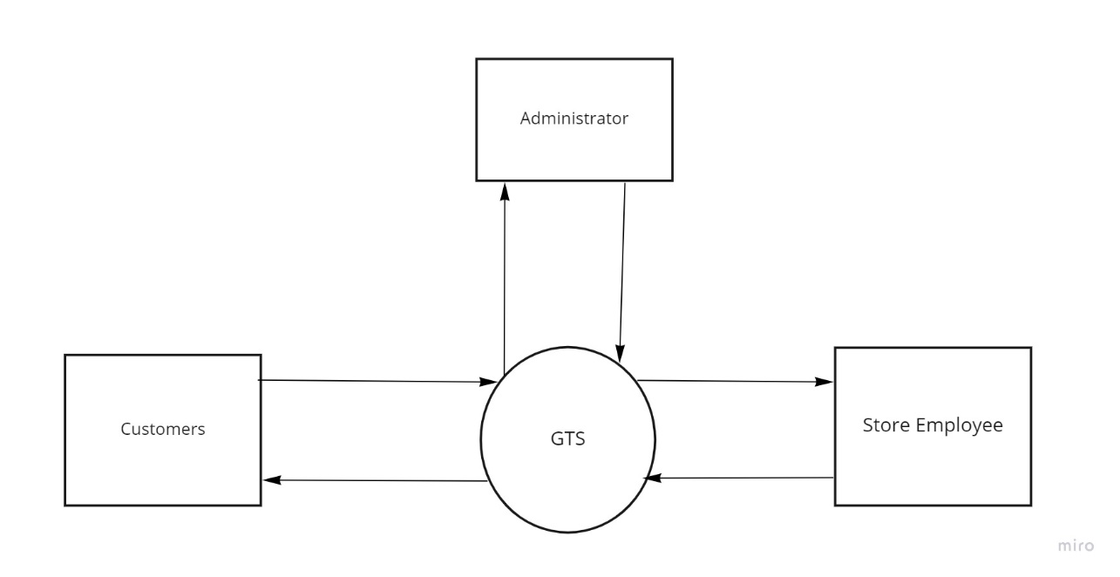
2. Level 1

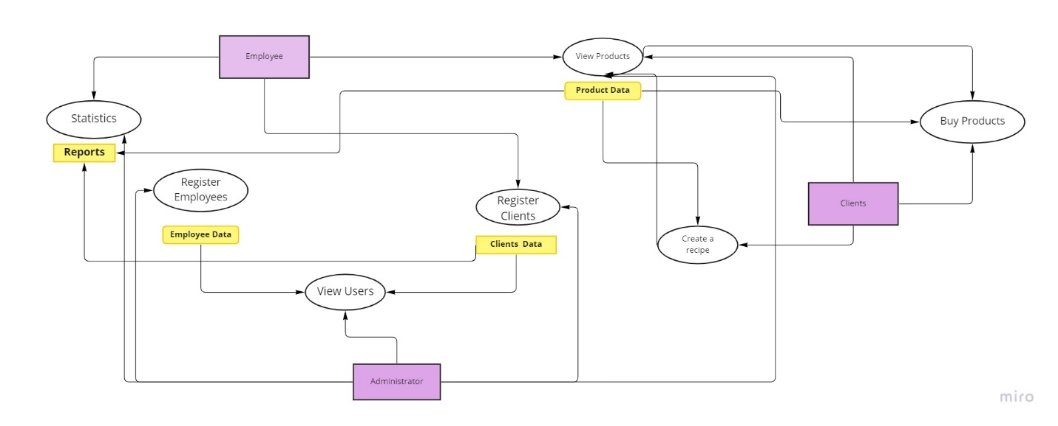

## ACTIVITY DIAGRAMS

### Activity Diagram 1 : Client

AC_1.1 and AC_1.2 Take the GT quiz

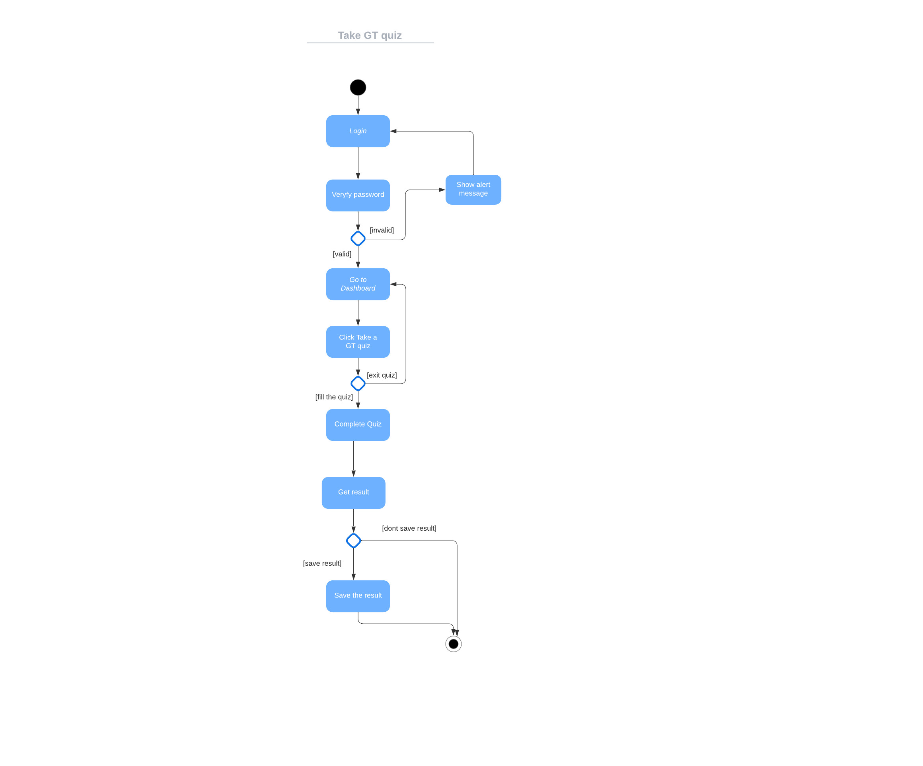

Activity 1.2 Personal Diary

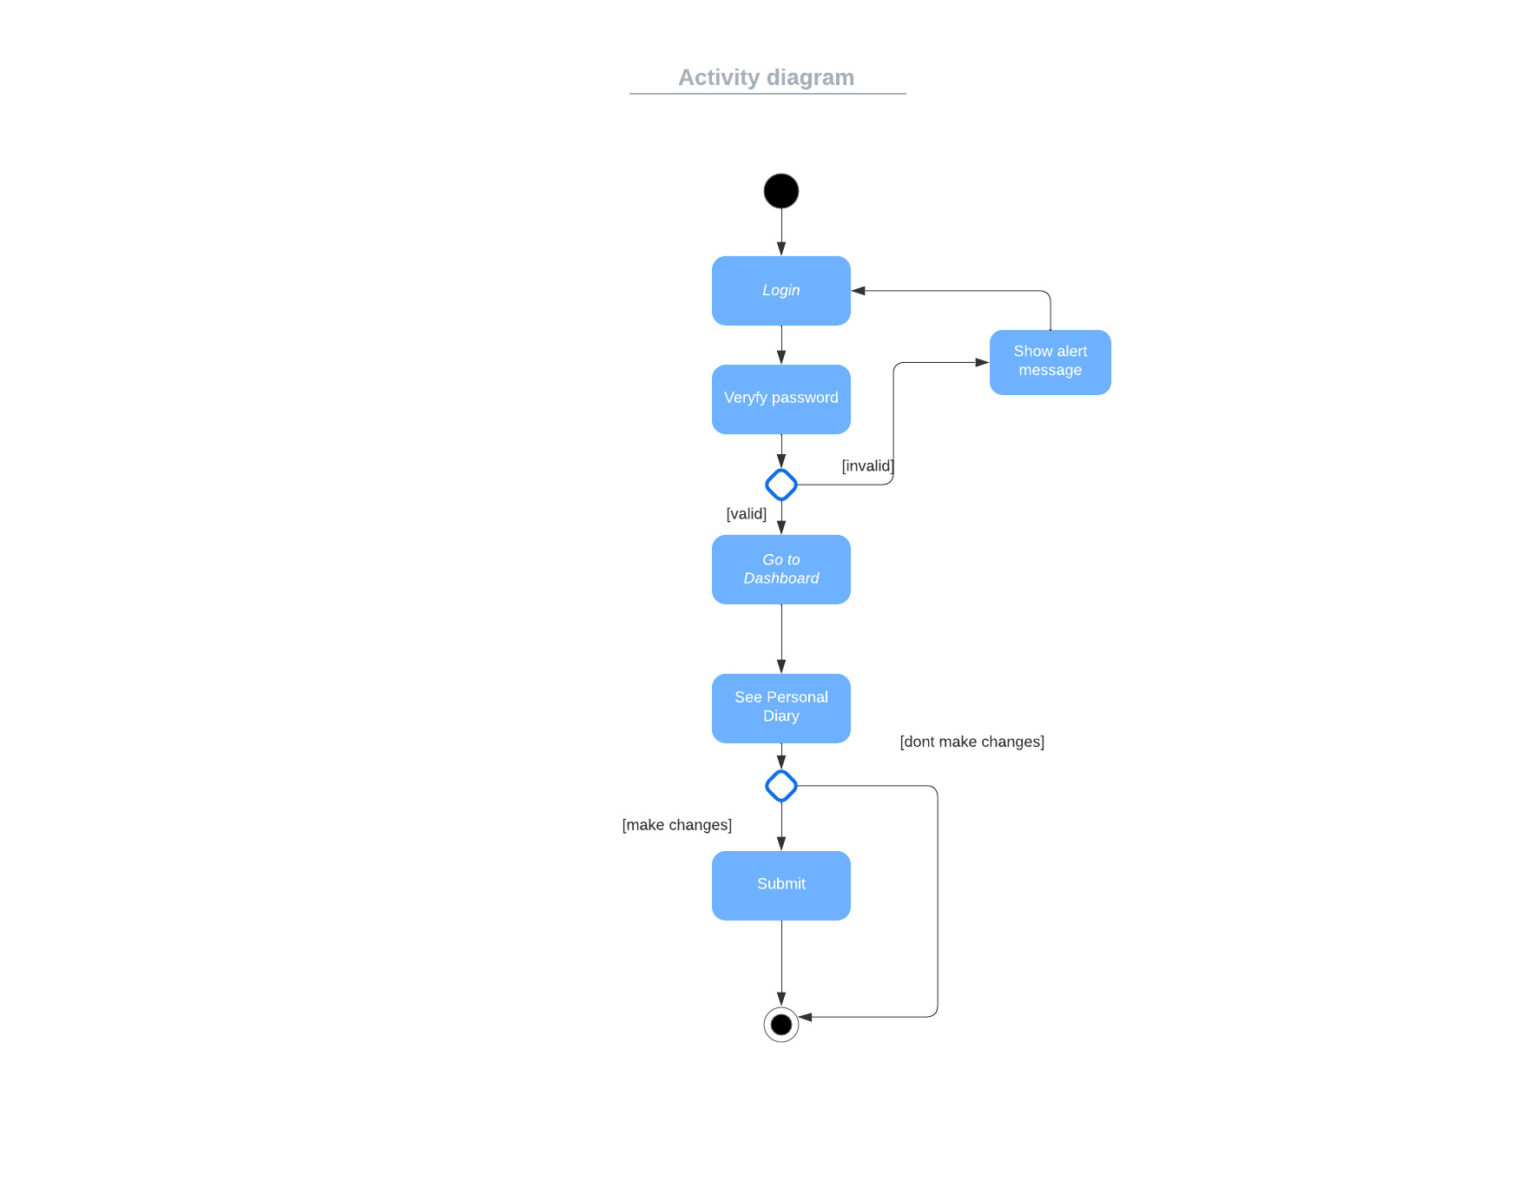

Activity Diagram 1.3 View Product

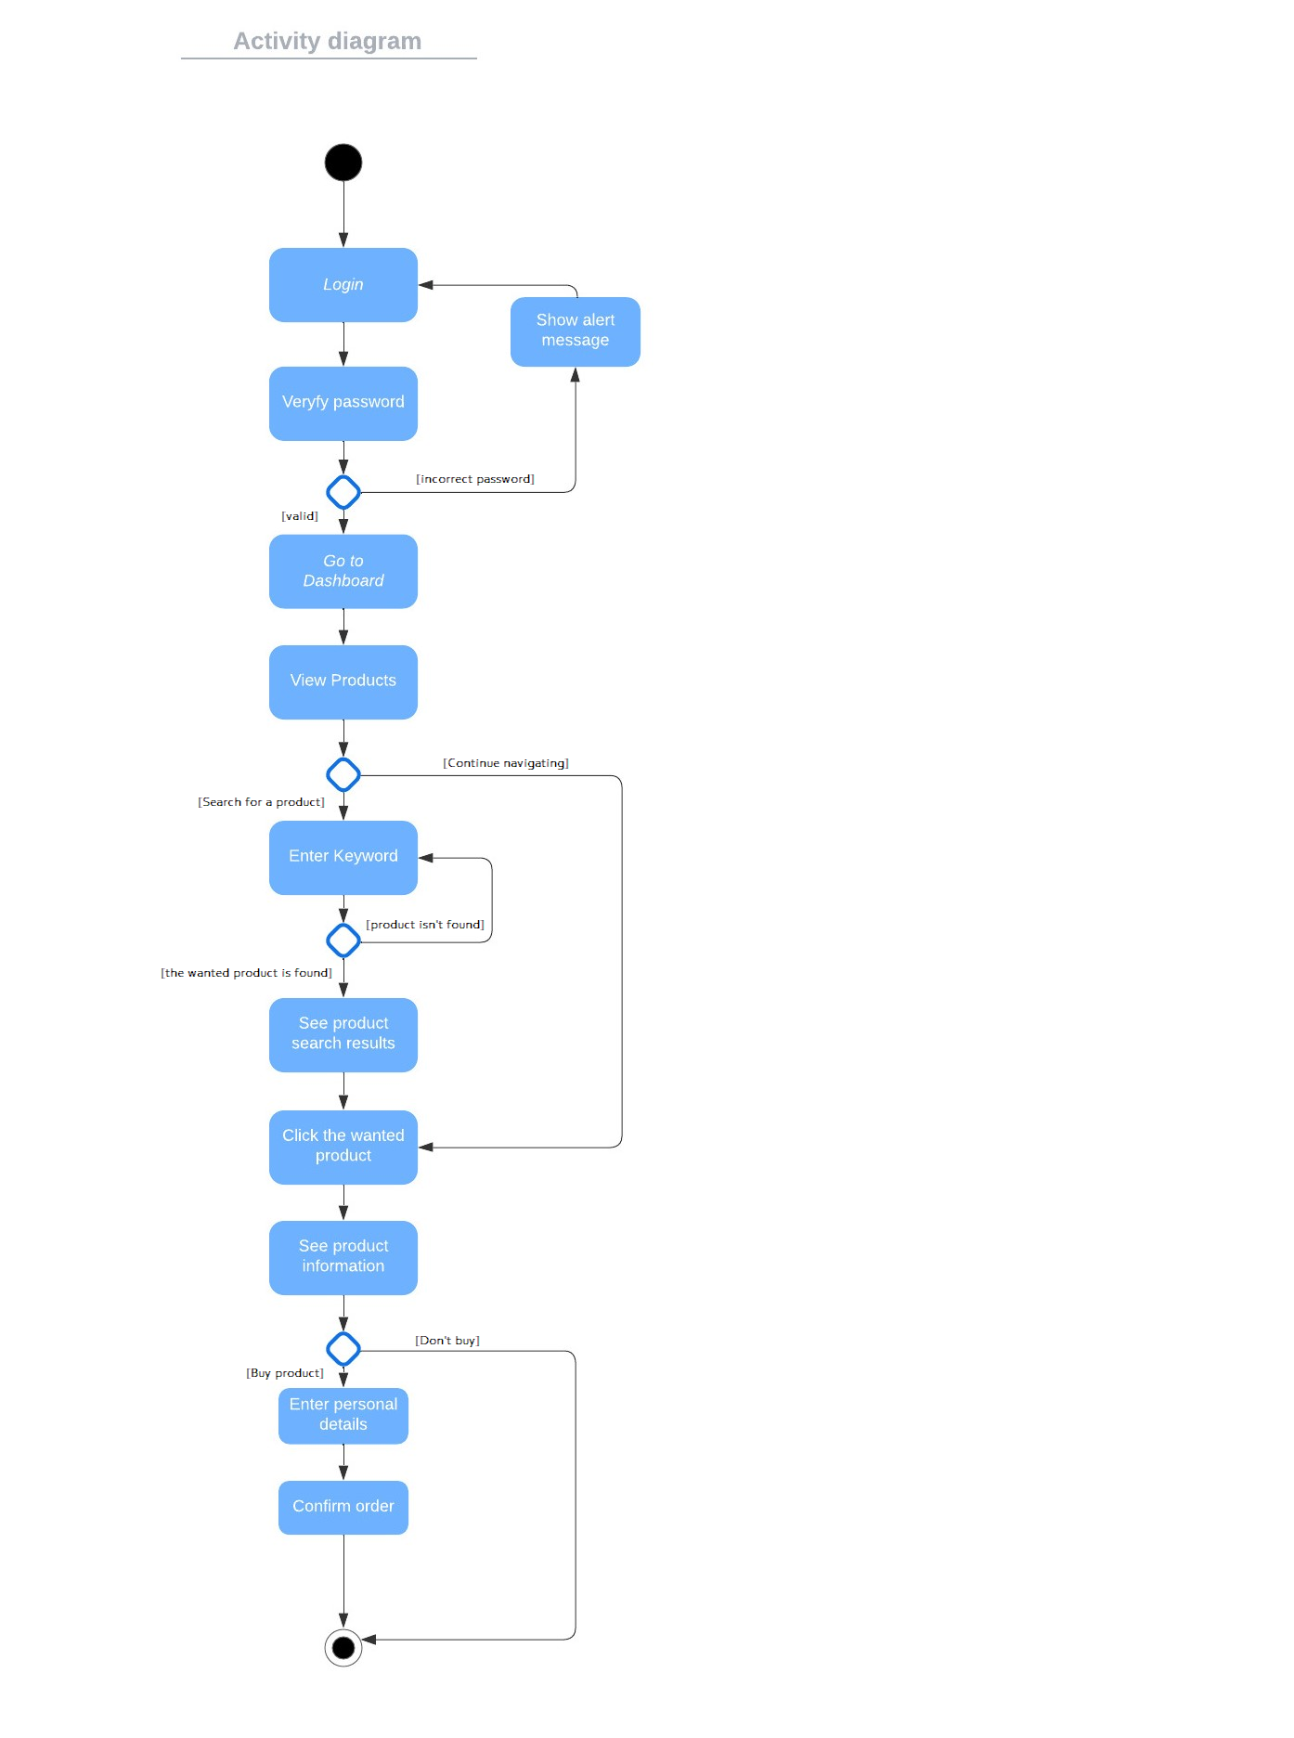

Activity 1.4 Send Message

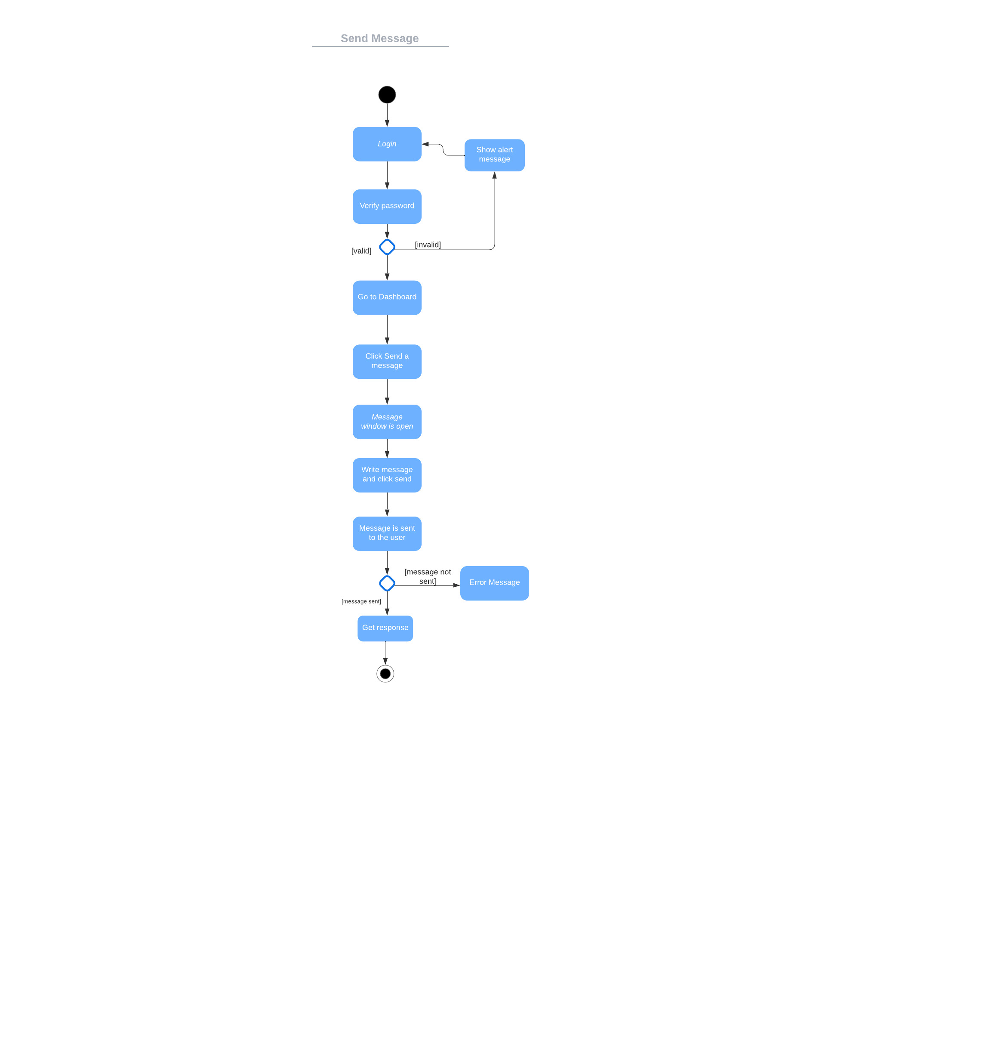

Activity 1.5 Write a comment

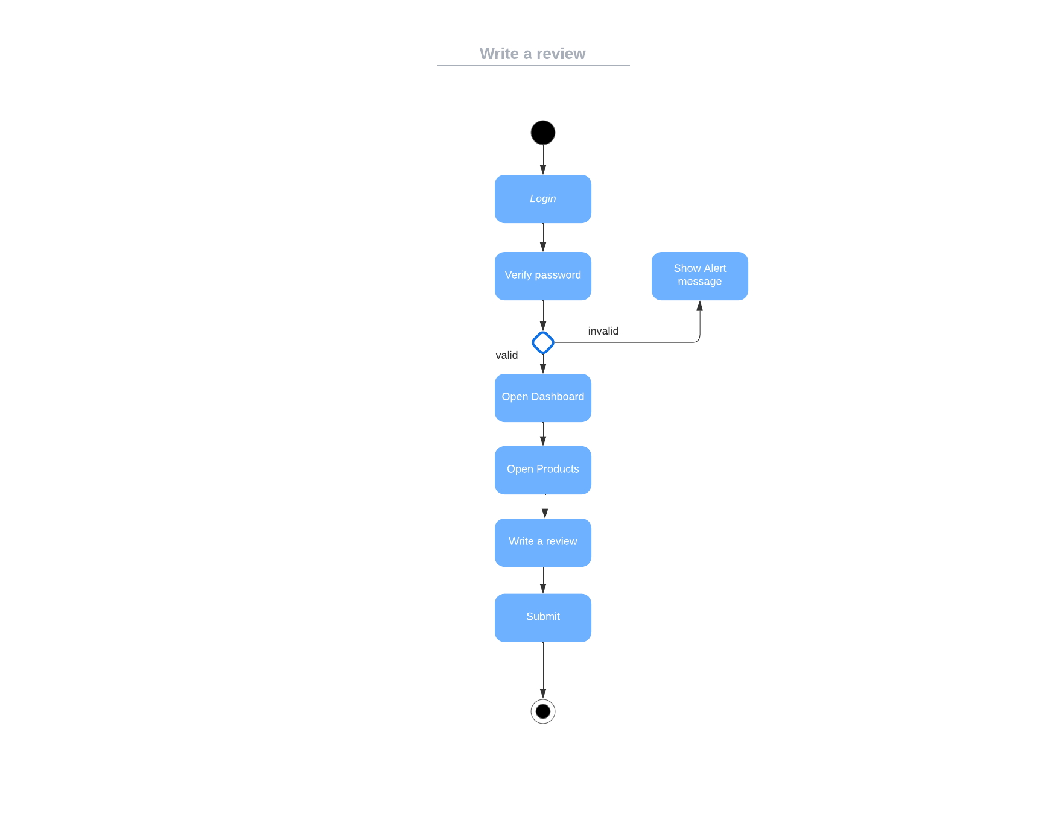

### Activity Diagram 2: ADMIN Representative

Activity 2.1 Register new User

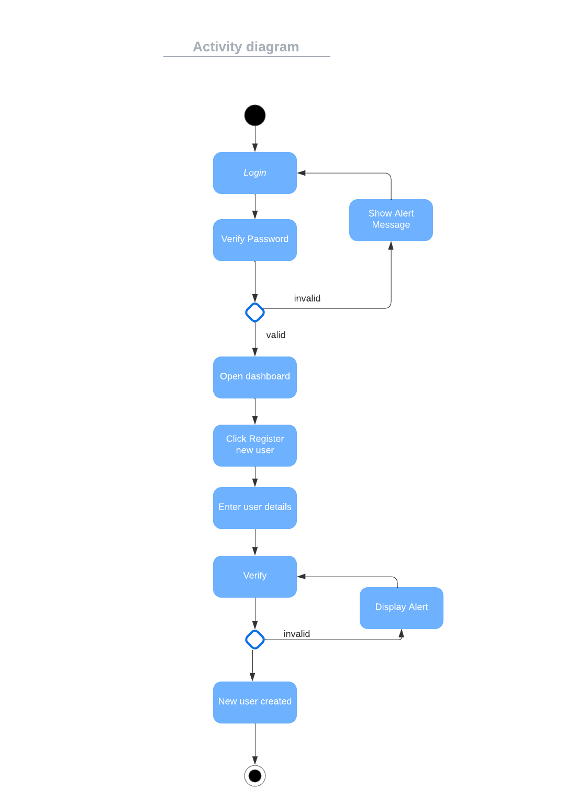

Activity 2.2 Delete an employee

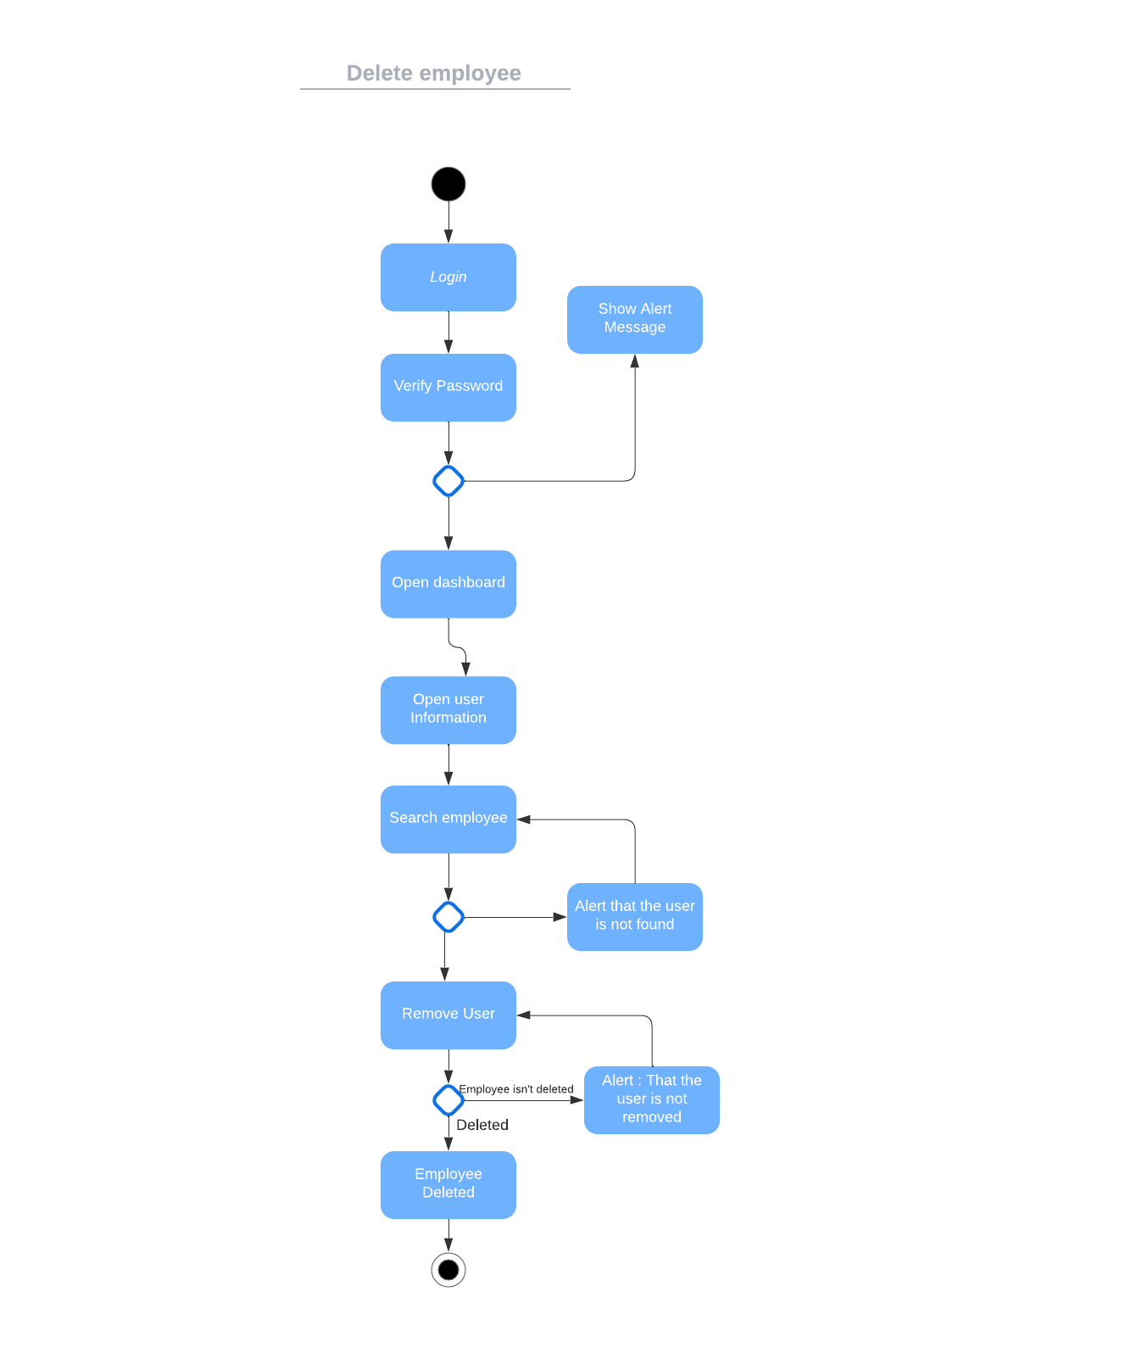

Activity 2.3 Get Statistics

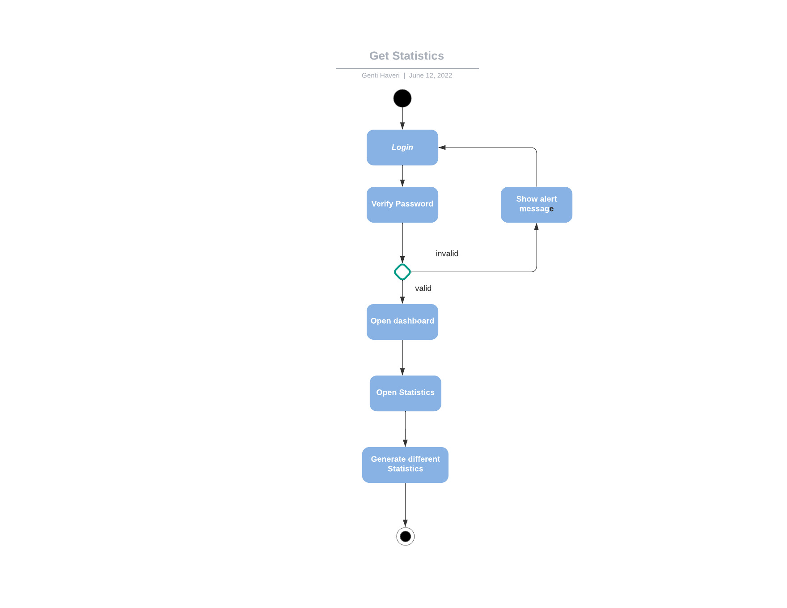

Activity 2.4 Get Message

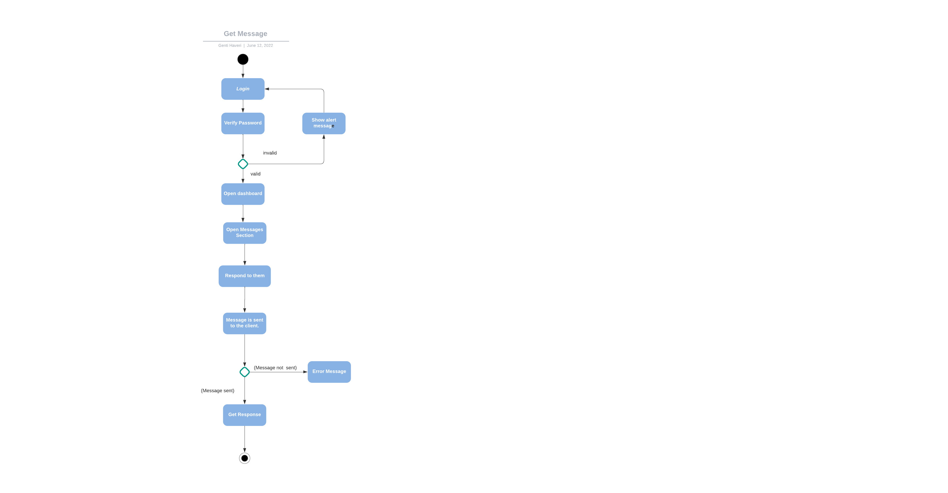

Activity 2.5 Export Data

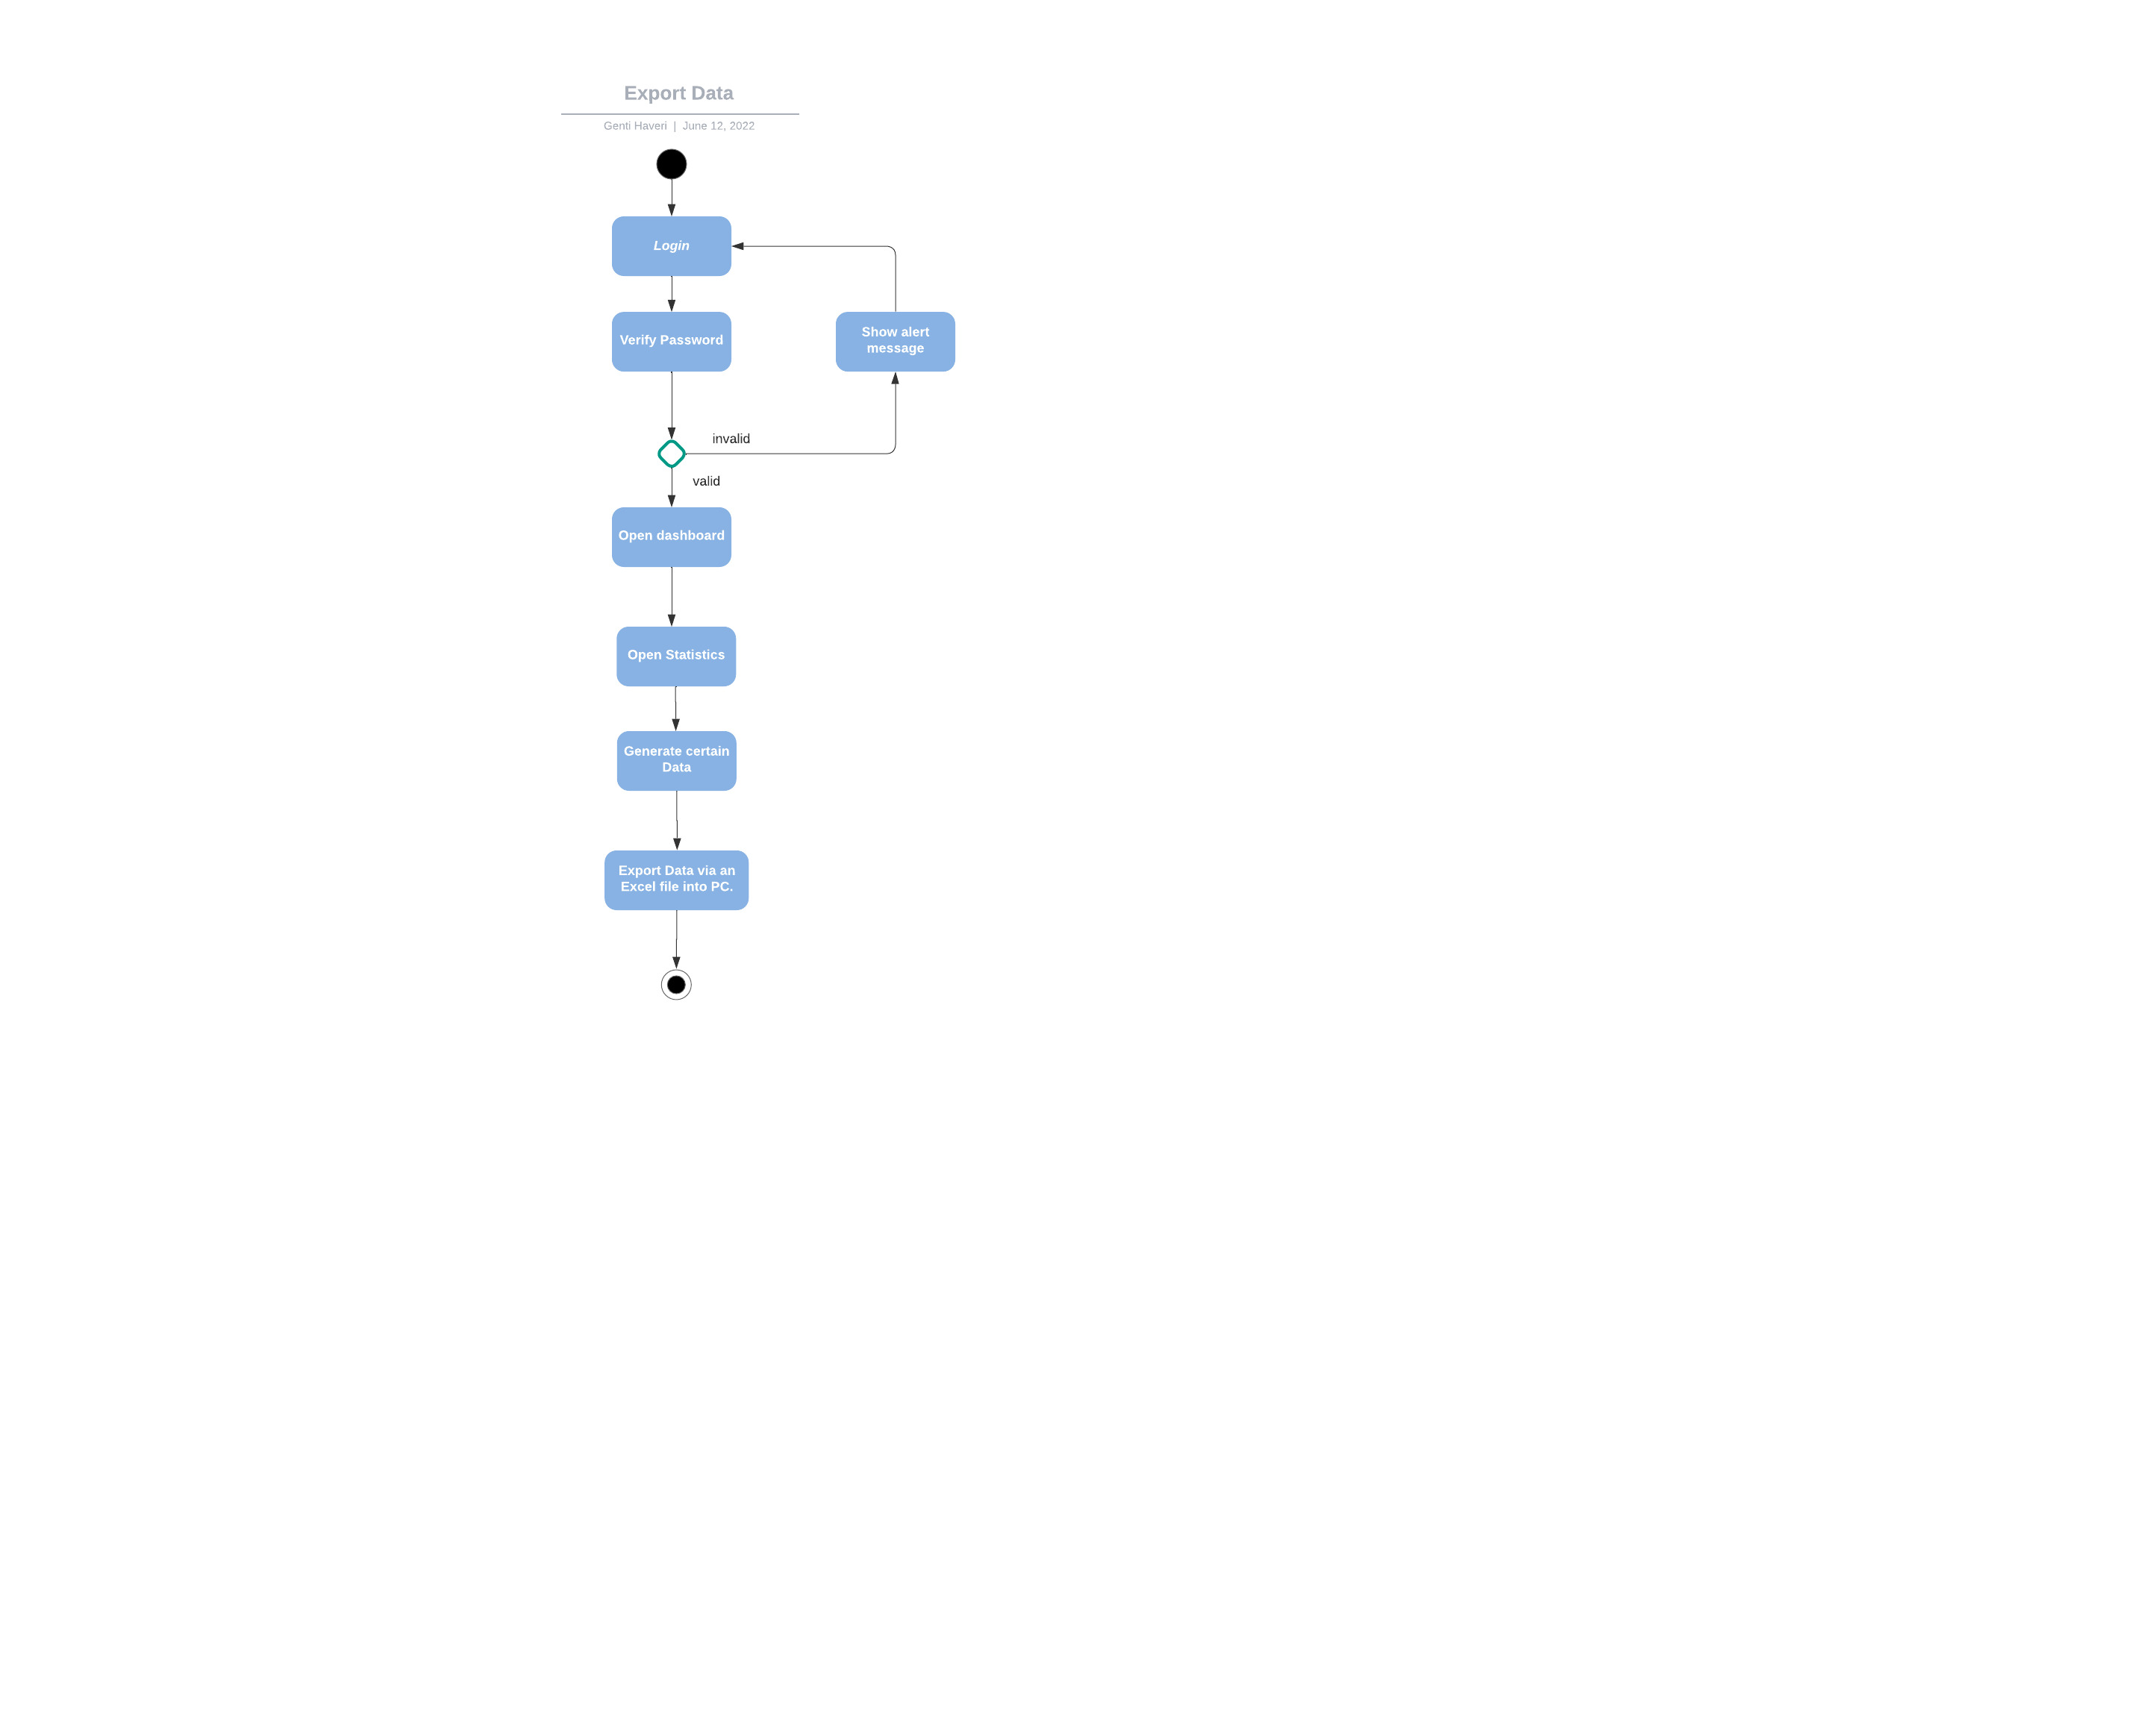

Activity 2.6 Update Products

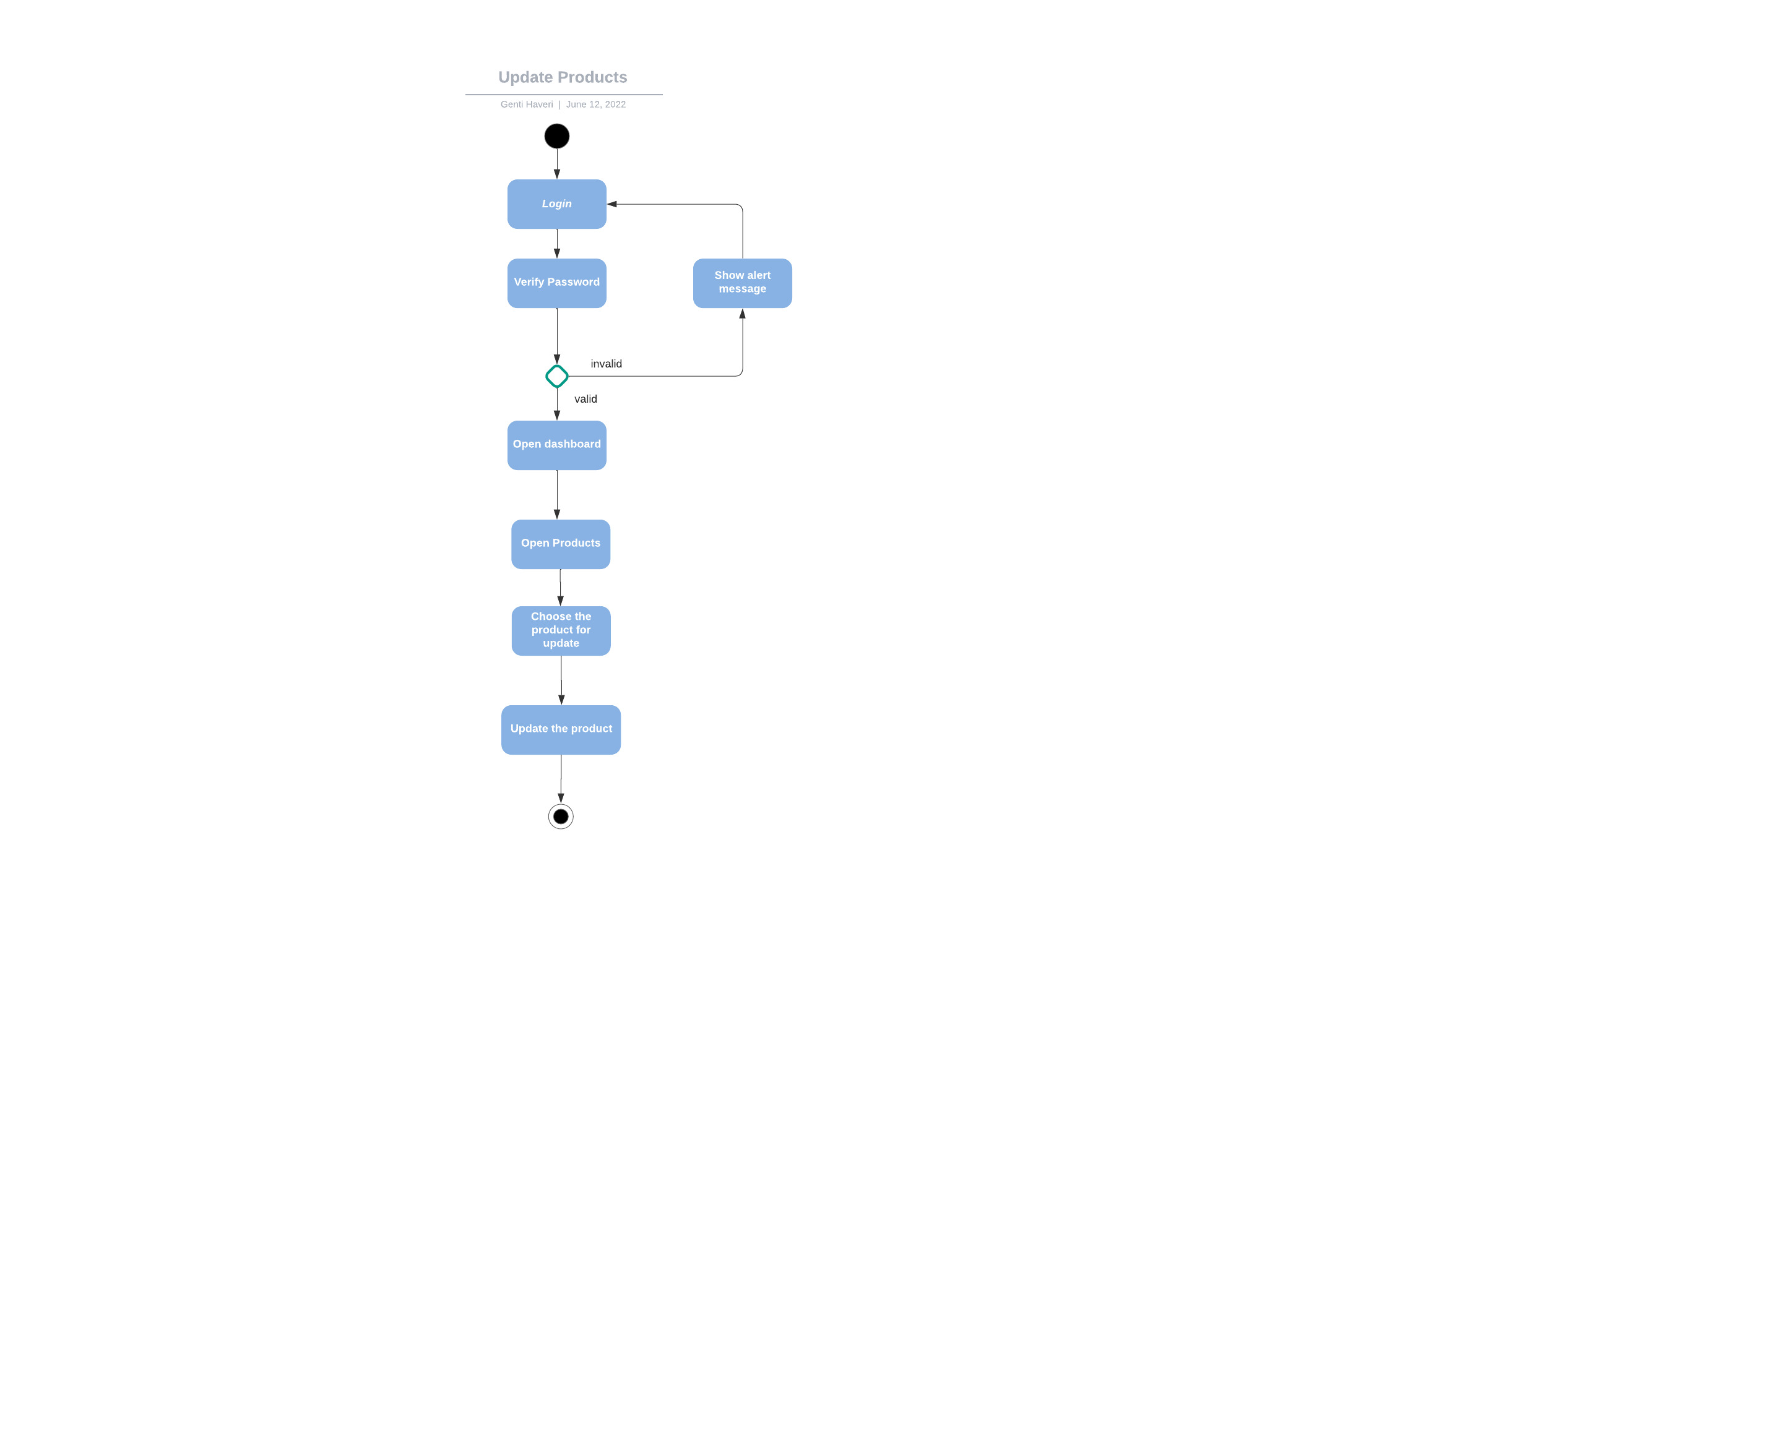

## STATE DIAGRAM

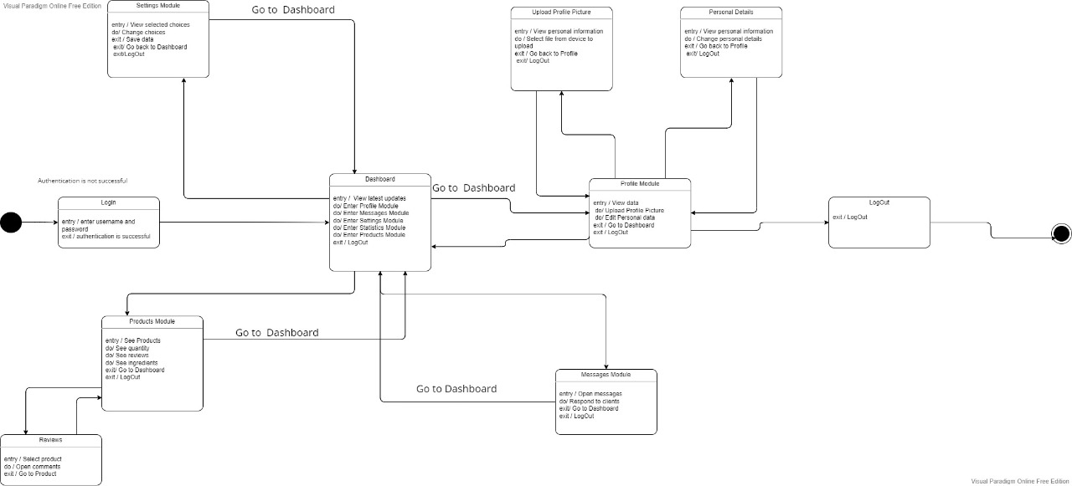

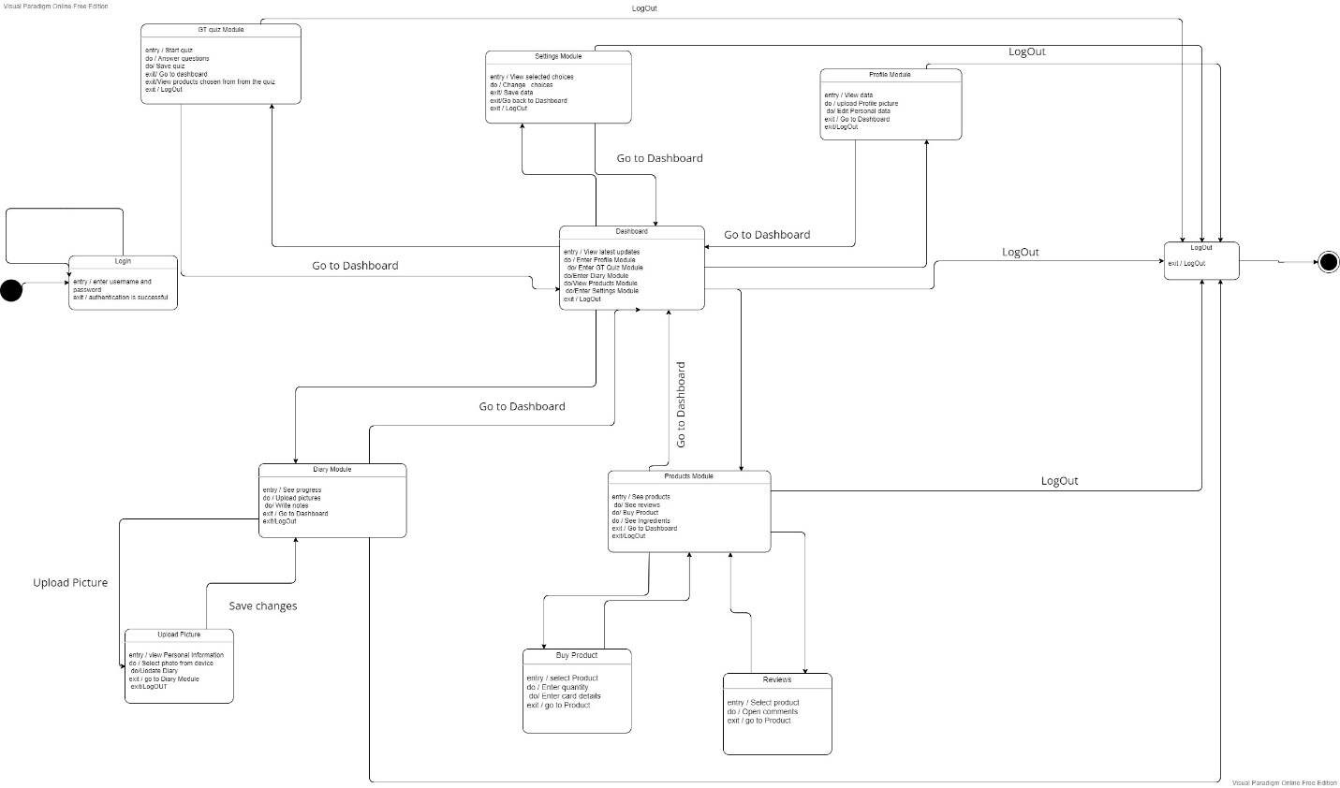

### STATE - REGISTER

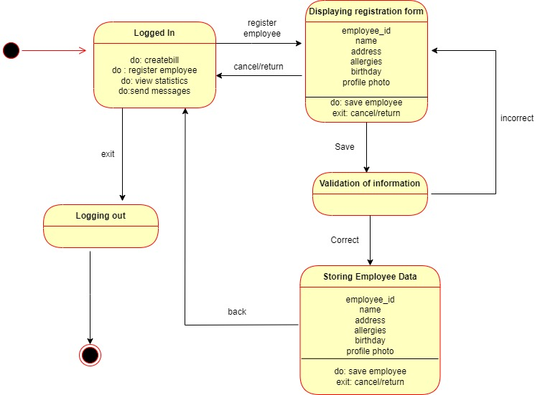

STATE – Update Product

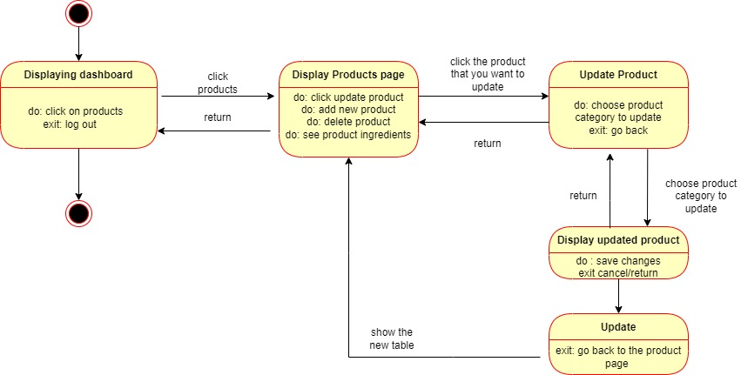

### State – Update Profile

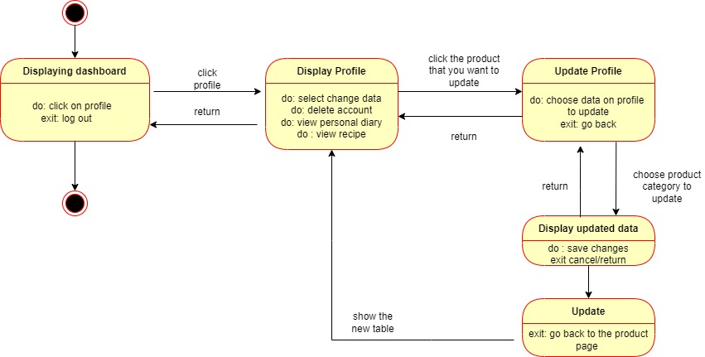

### State – Open Recipe

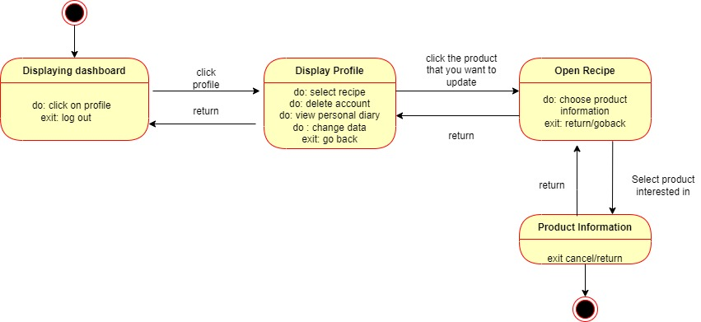

### State – Product Statistics

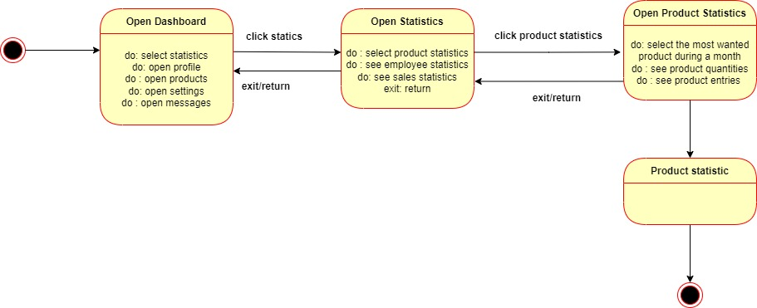

State – Employee Statistics

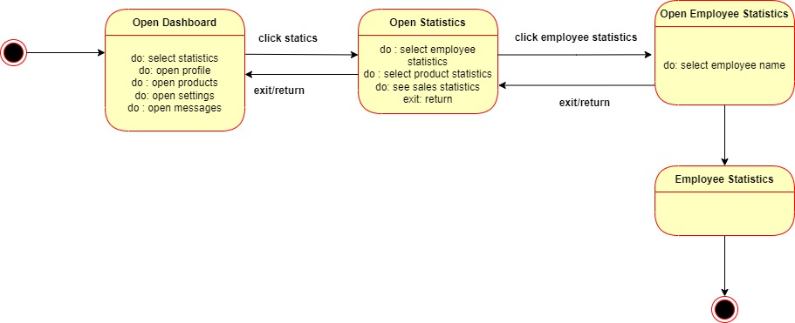

State – Buy a Product

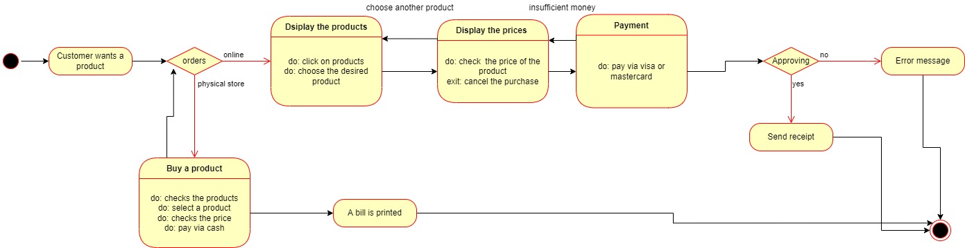

State – Write a Message

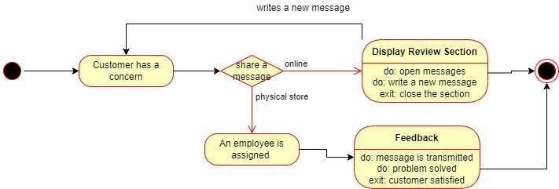

Sequence Diagrams

Sequence – Product Statistic

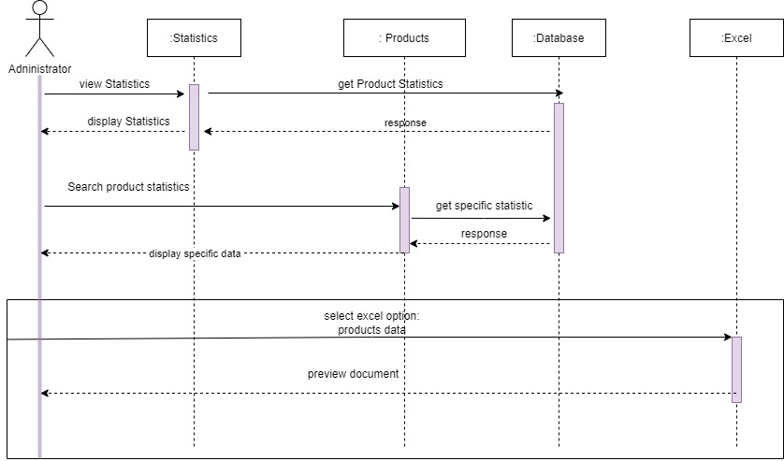

Sequence – Manage Employee

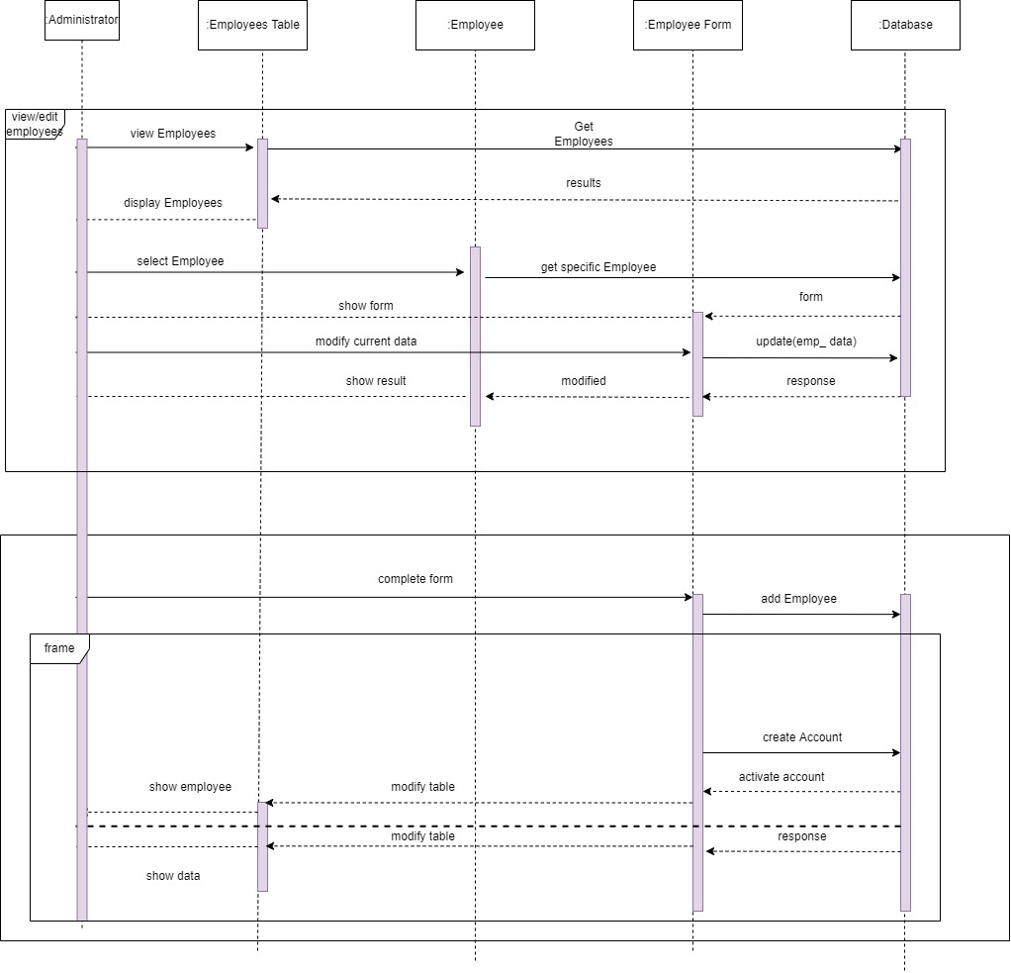

Sequence- Product Info

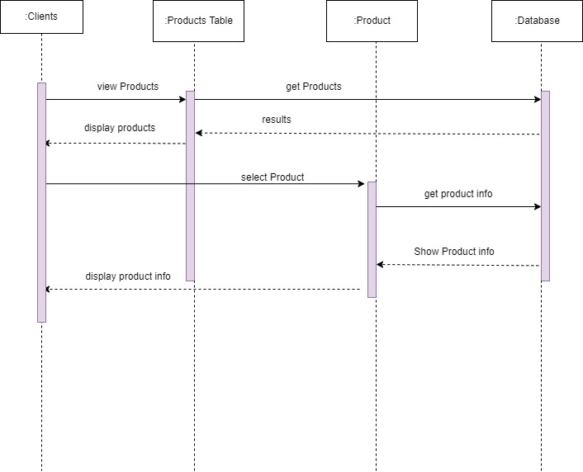

Sequence – Authentication

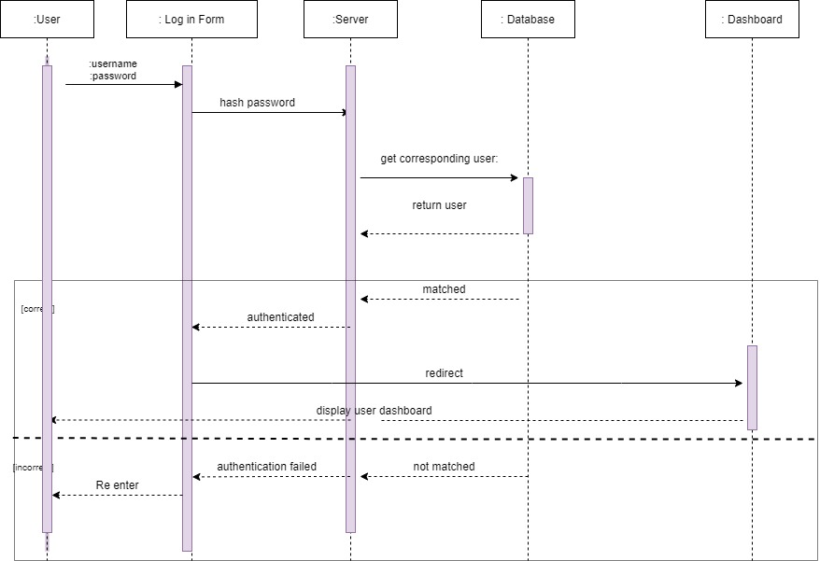

Sequence – View Shopping Bag

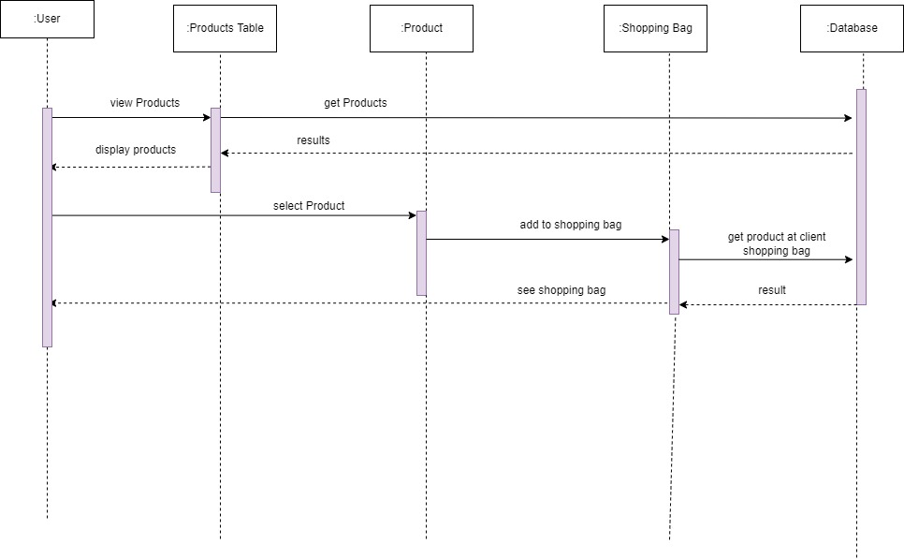

Sequence – Statistics

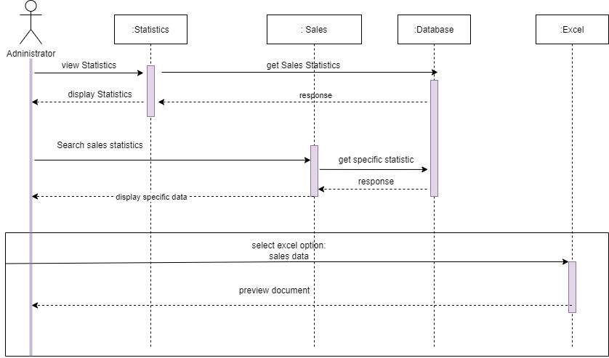

Sequence – Update Profile

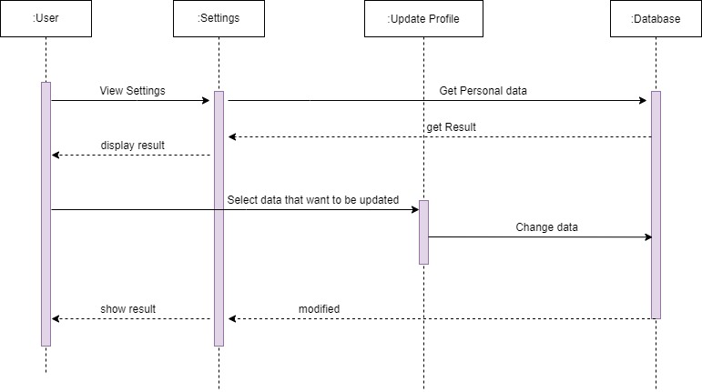

## Collaboration Diagrams

### AUTHENTICATION

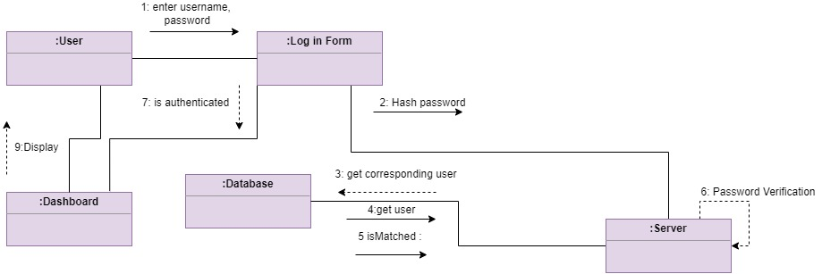

### Manage Employees

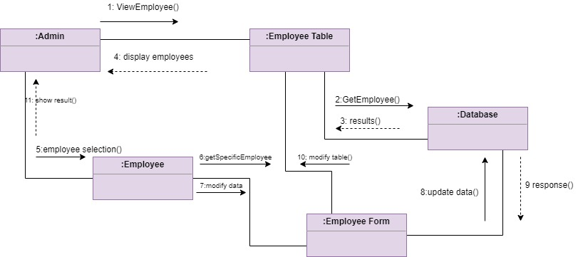

### Product Information

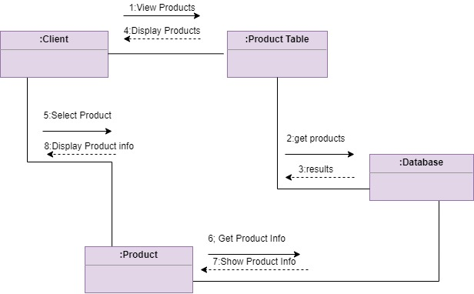

### Product Statistic

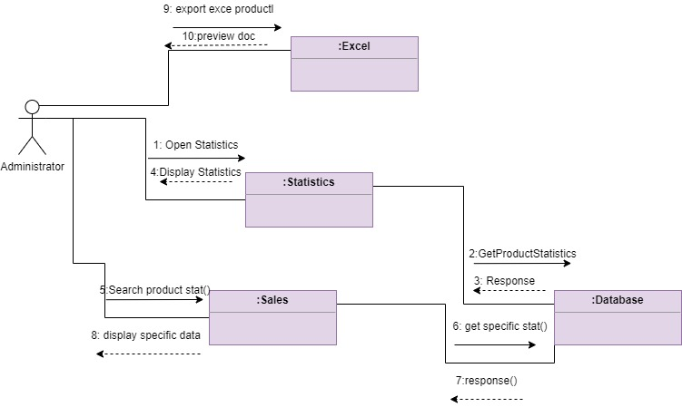

### Sales Statistic

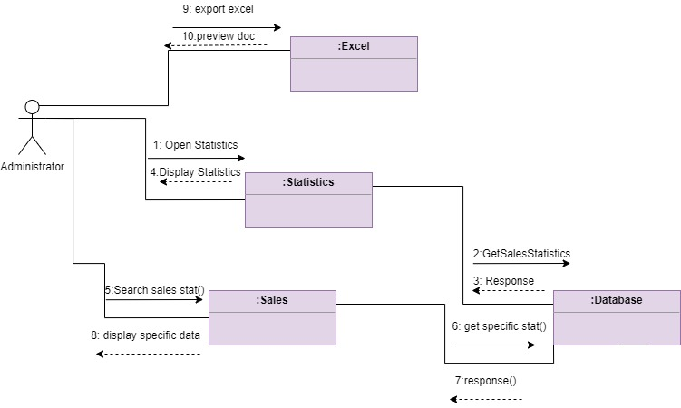

#### Shopping Bag

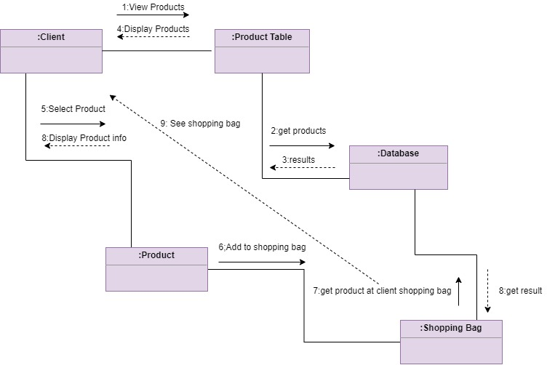

#### Update Profile

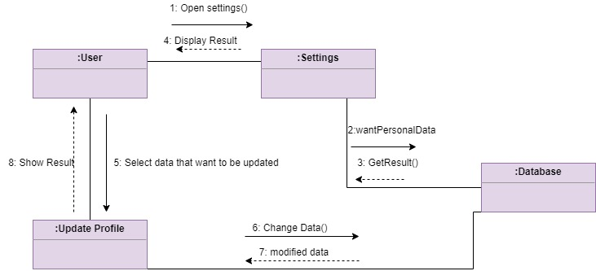

### CLASS DIAGRAM

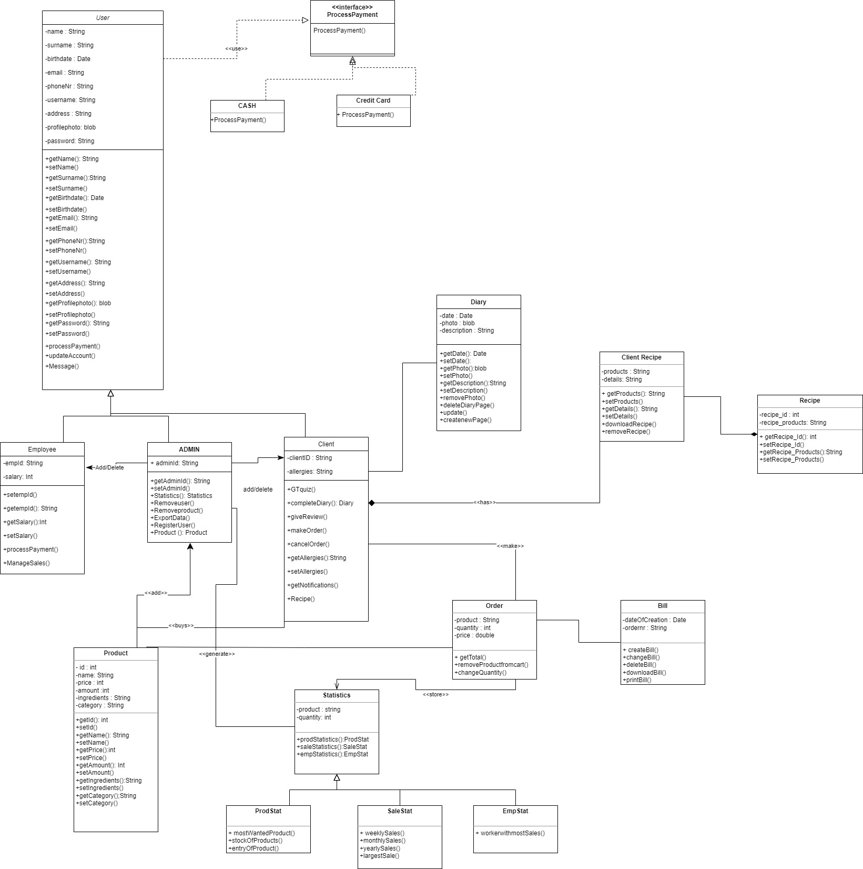

### OBJECT DIAGRAM

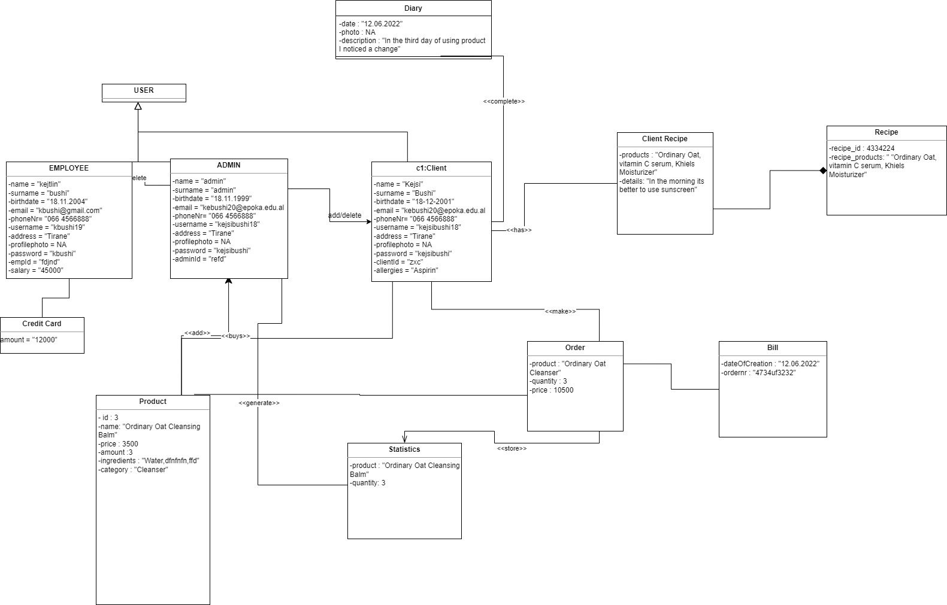

### OBJECT DIAGRAM 2:

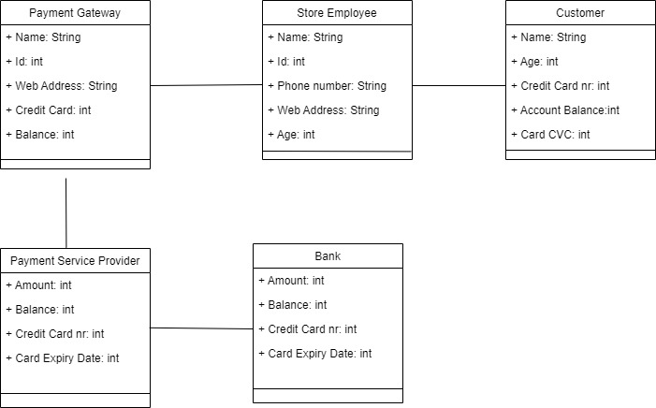

### ERD DIAGRAM

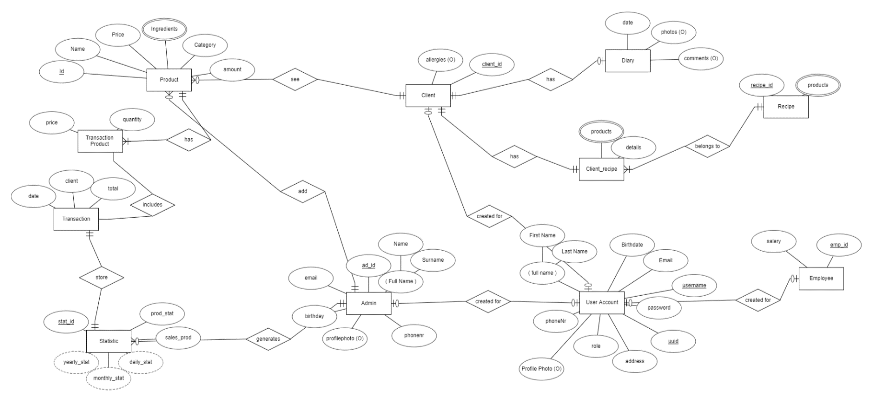

### RELATIONAL SCHEMA

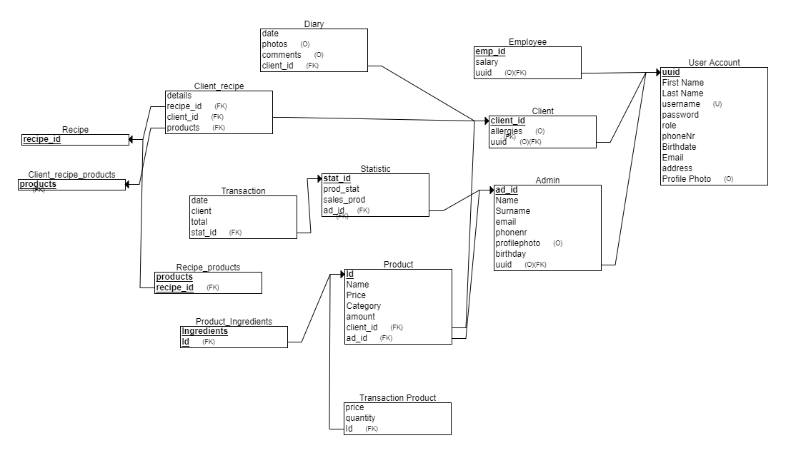

COMPONENT DIAGRAM

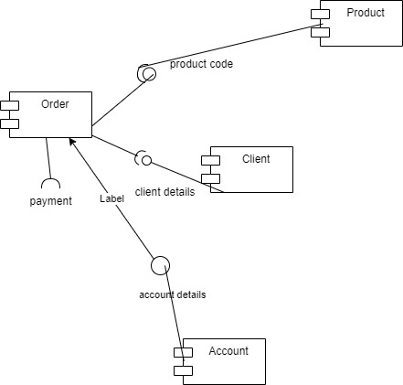

Deployment

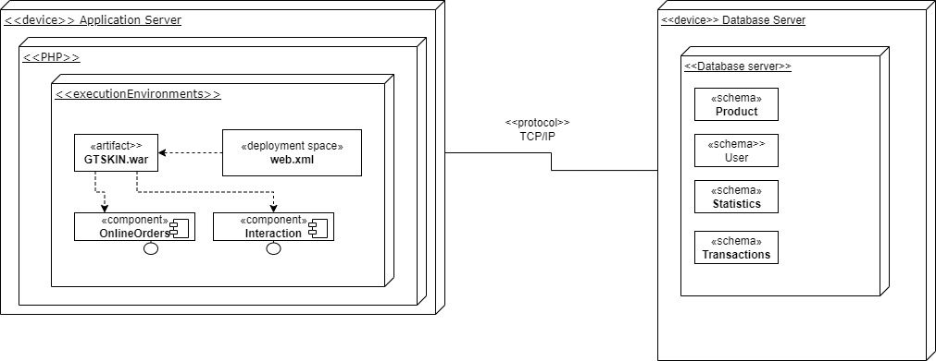

## **DESIGN PATTERNS**

After researching Design Patterns and how they function we have decided the following design patterns

**Factory Method Design Pattern –** Since in our website we have the option to make payments in two different ways which are with credit card or cash, factory method design pattern will help us with this action(choosing between different types of payments)This design pattern is used in case when a class doesn’t know what sub-classes will be required.This pattern will also help us when ADMIN would want to generate between three types of statistics(Employee,Product, Sales).

**Template Method Design Pattern** – Our website has three module users and each of them have their own characteristics. That is why is useful to use a pattern like Template Method Design Pattern in order to have a structured program.

As seen above have a superclass like User that has three subclasses : Client, Admin and Employer. With Template Method design patterns it provides in our case three different templates depending on the user that has entered the program.

**Observer Design Pattern** – One of the features that our group has is notifying when a product is out of stock or when a desire product is wanted. For this part Observer Design Pattern is a pattern that we thought that is useful. In our case when a product is at the store it will notify all the clients that are interested in that product.

**Prototype Design Pattern**– One of the features that our program has is getting the bill downloaded after making a purchase but also downloading a copy of the statistics.

## 

## **Architecture**

MVC Architecture is the Architecture that our group has decided to follow for this project. MVC stands for Model View and Design.

**Model** – is the first component that helped us in creating this website. We know that the model help us in creating a data logic. During all these time diagrams like ERD, Use cases etc has helped us model how the website is going to work.

**View** – is the second component. In our website there are four different views: Visitor View, Customer View, Employee View and Admin View. Each view has its own options that differentiates from the other. For example Admin has access into adding, removing products or even get statistics, meanwhile a customer or a visitor cannot.

**Controller** – the third component connects Model with View and make everything accessible. In our website we have forms, buttons checkboxes that make the connection with the first two components.

## Prototype

**Main Page**

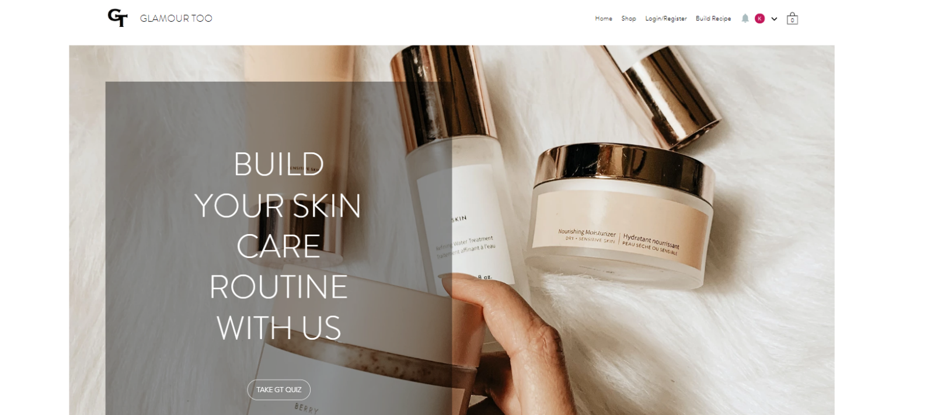

**Main Page.2**

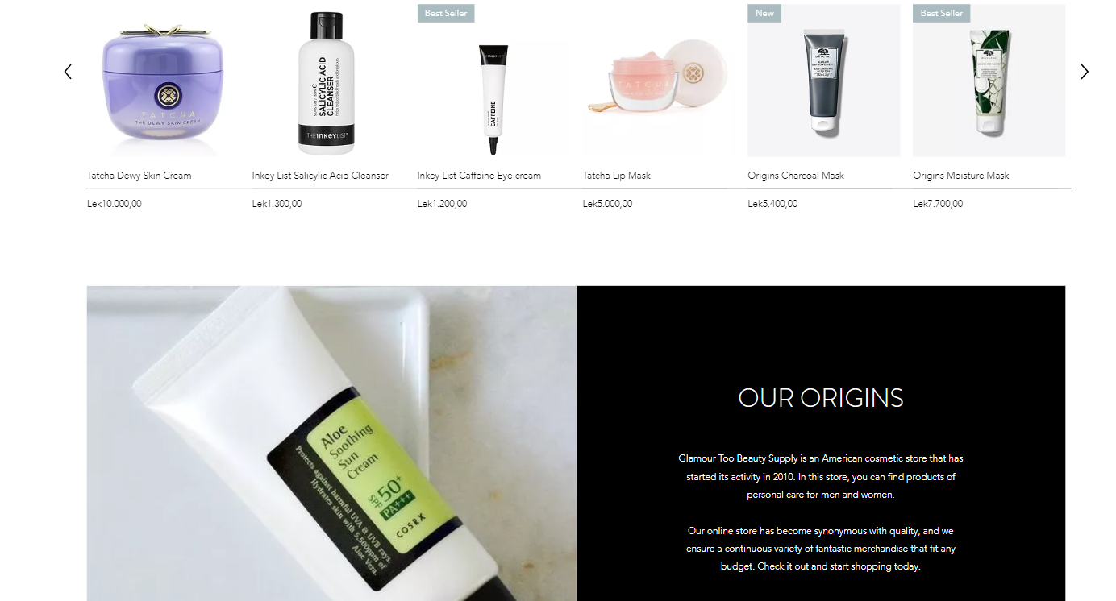

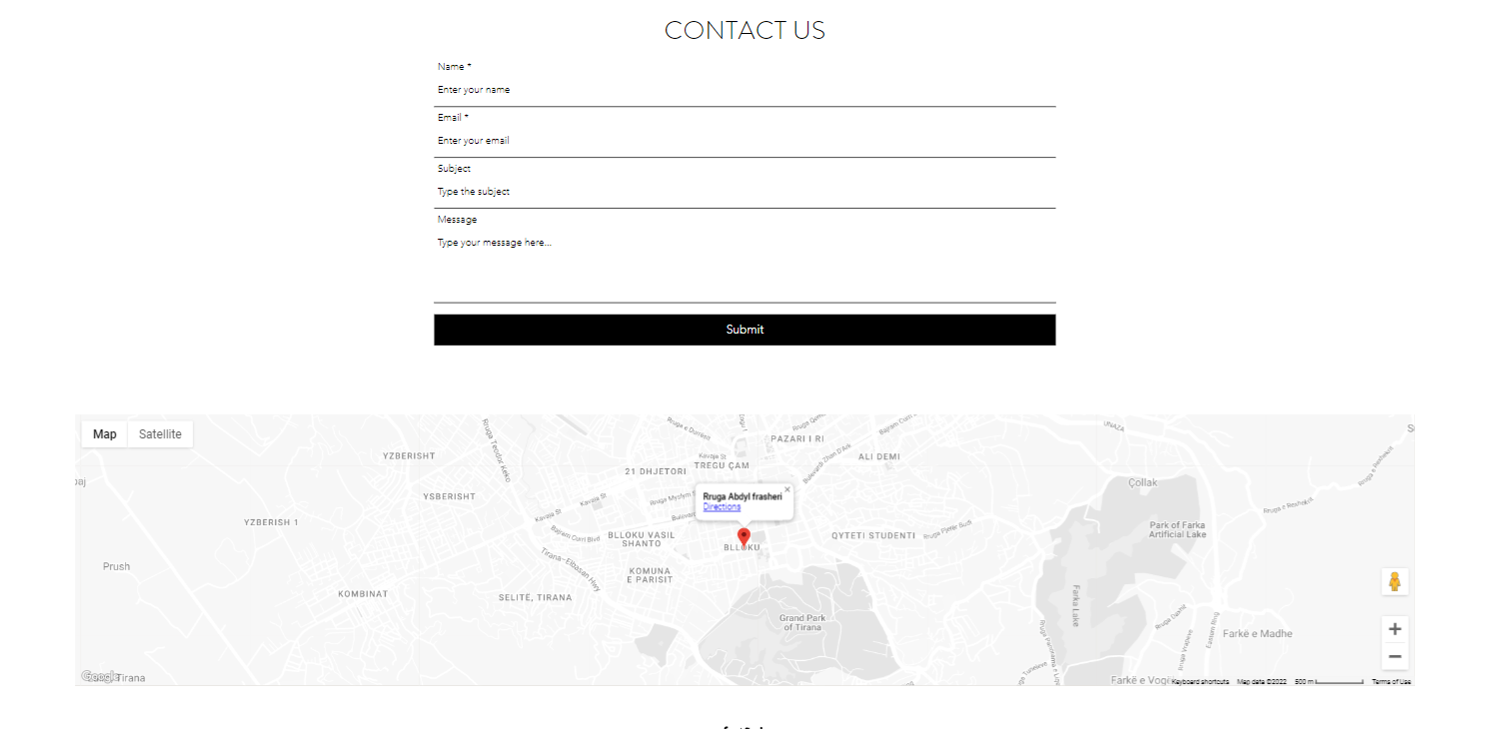

**GT QUIZ**

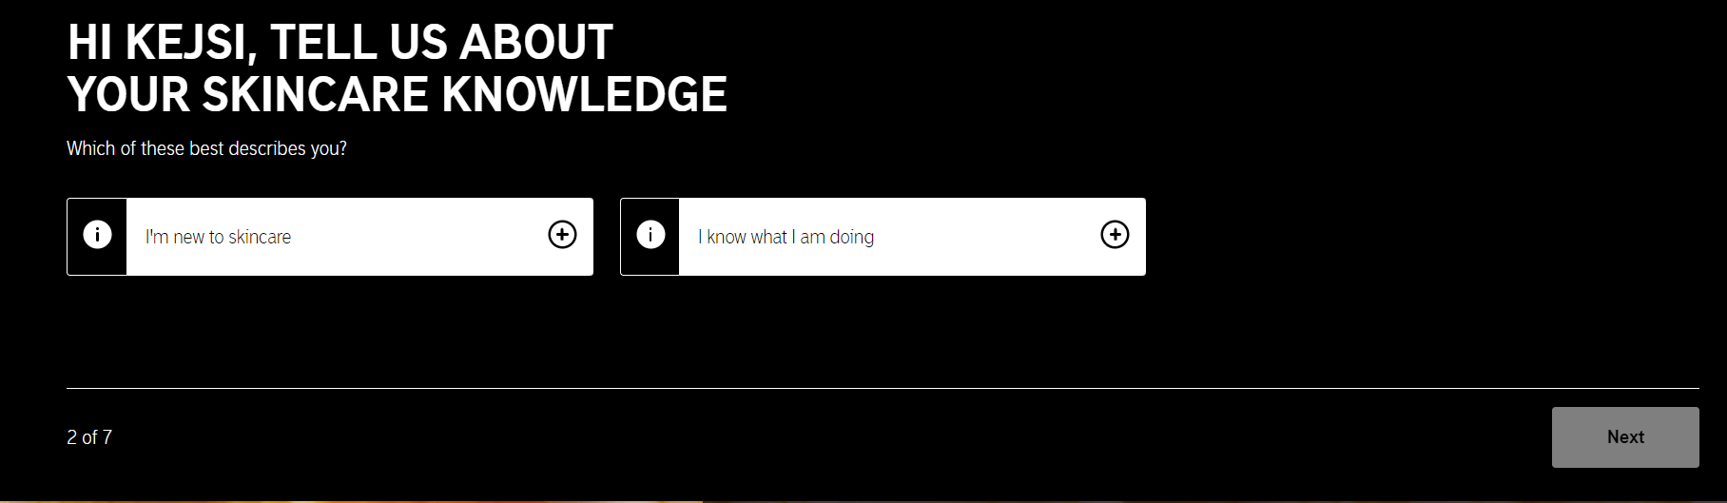

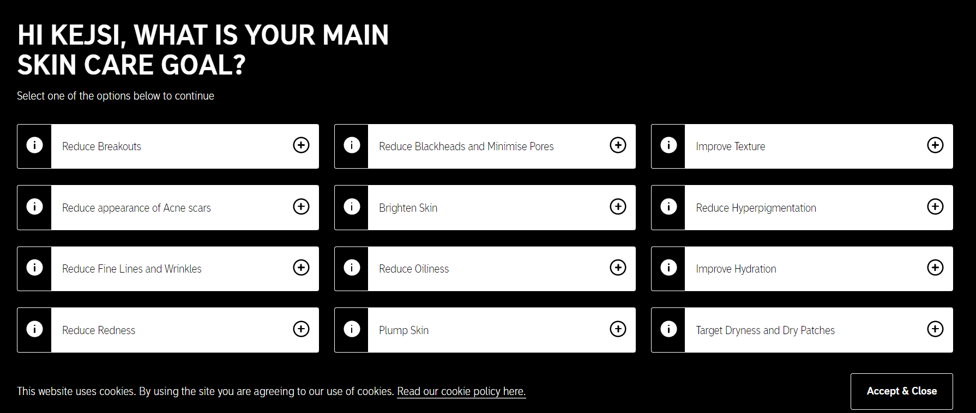

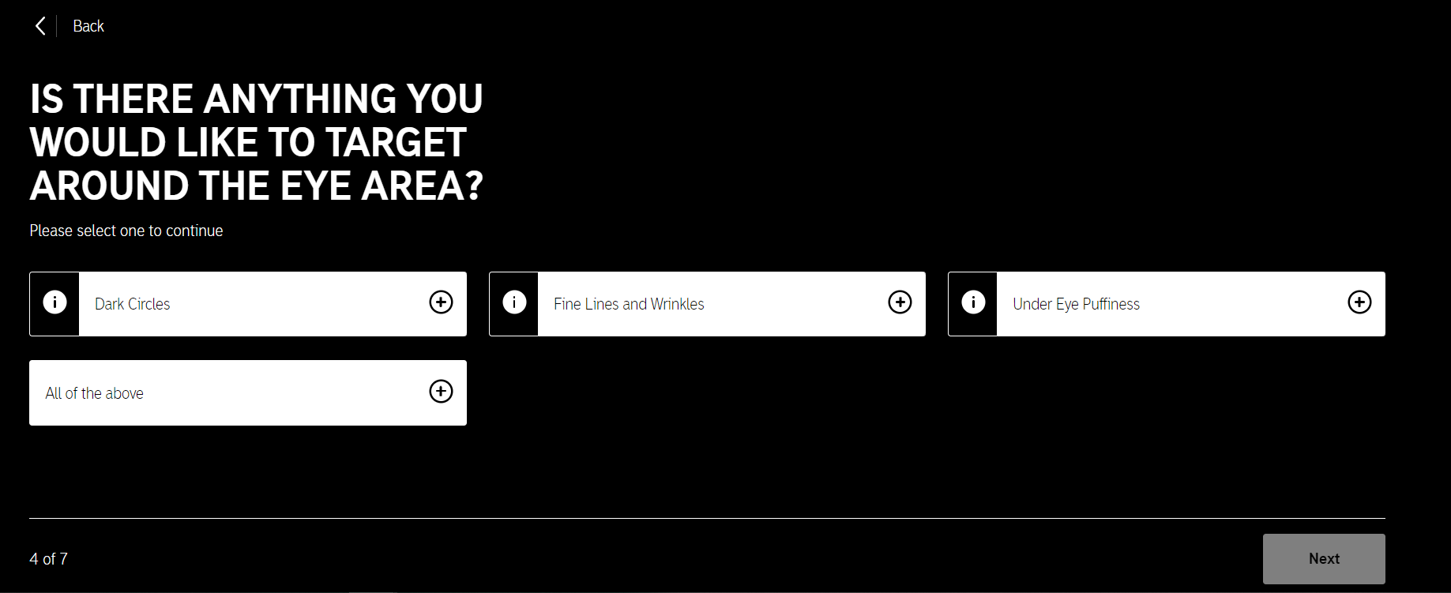

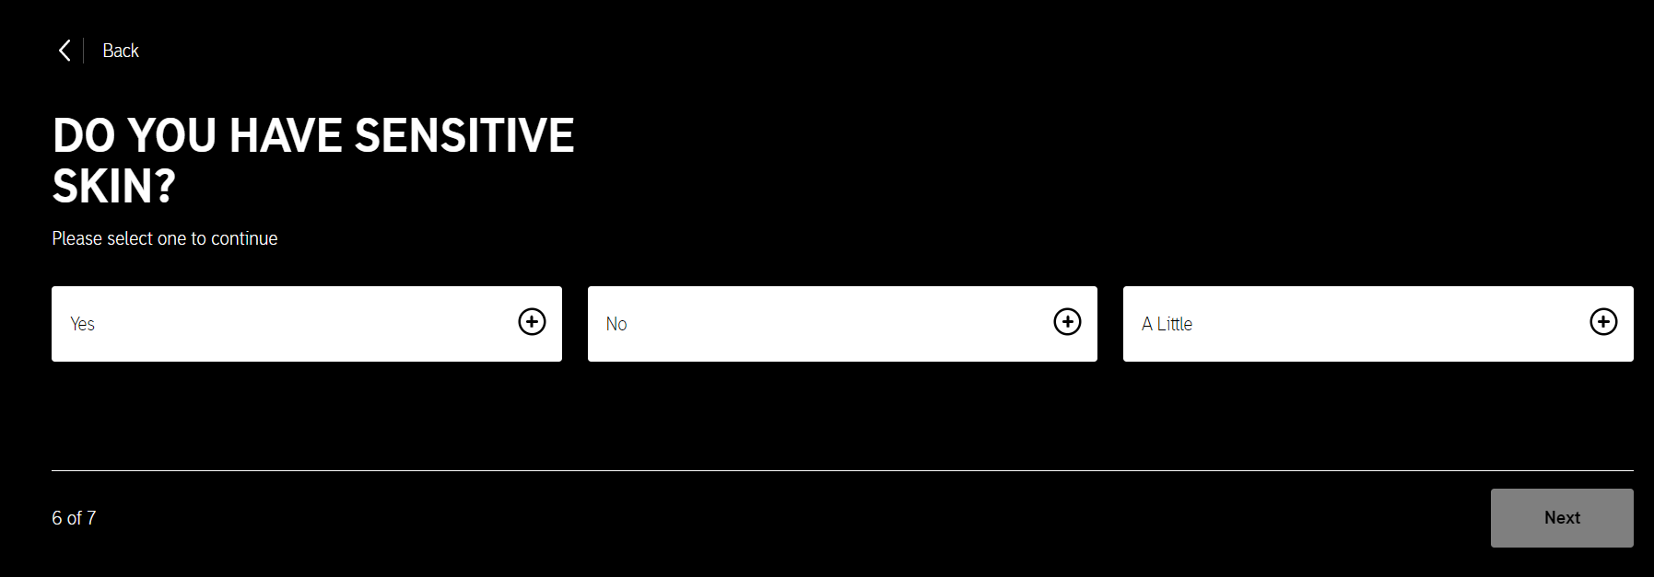

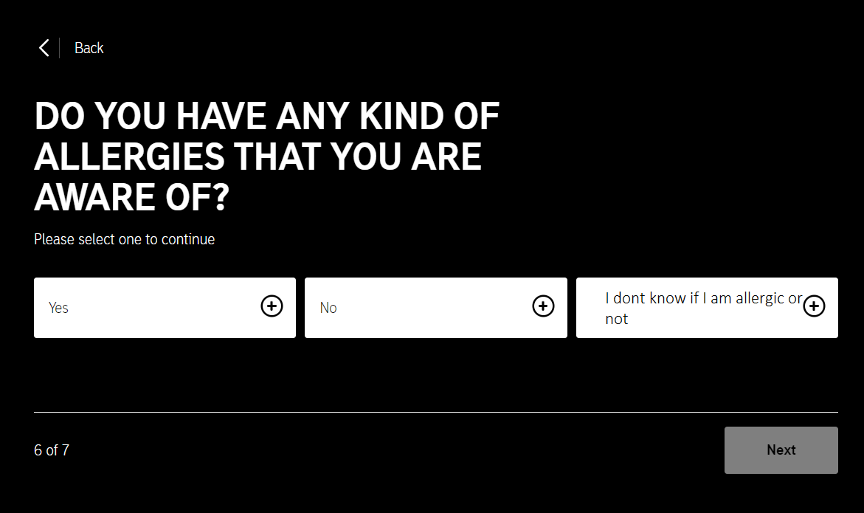

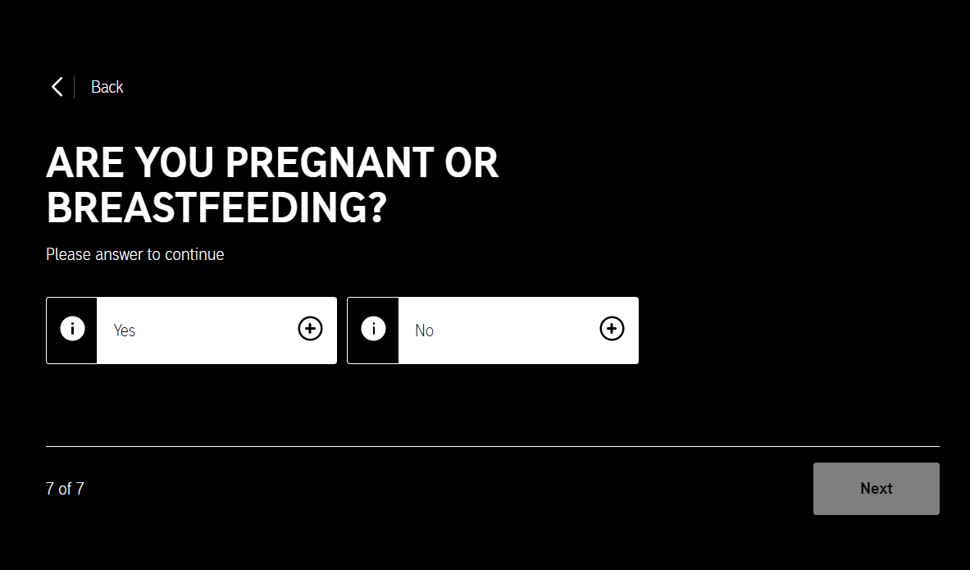

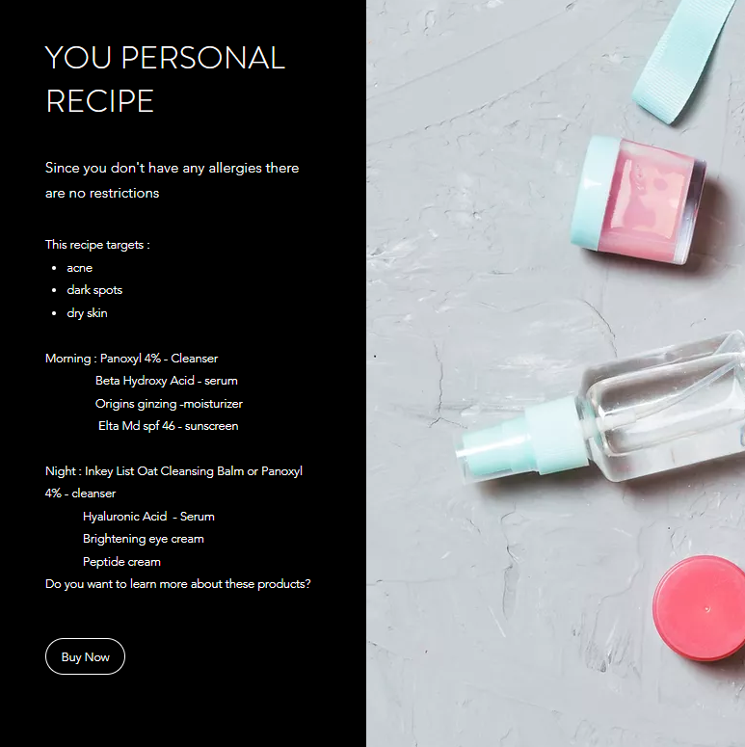

**Statistics**

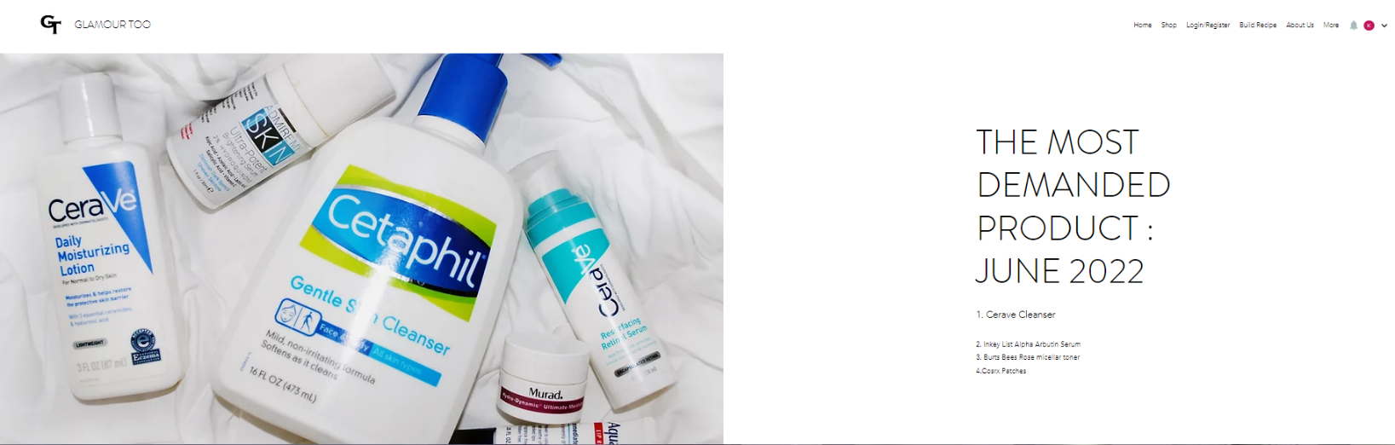

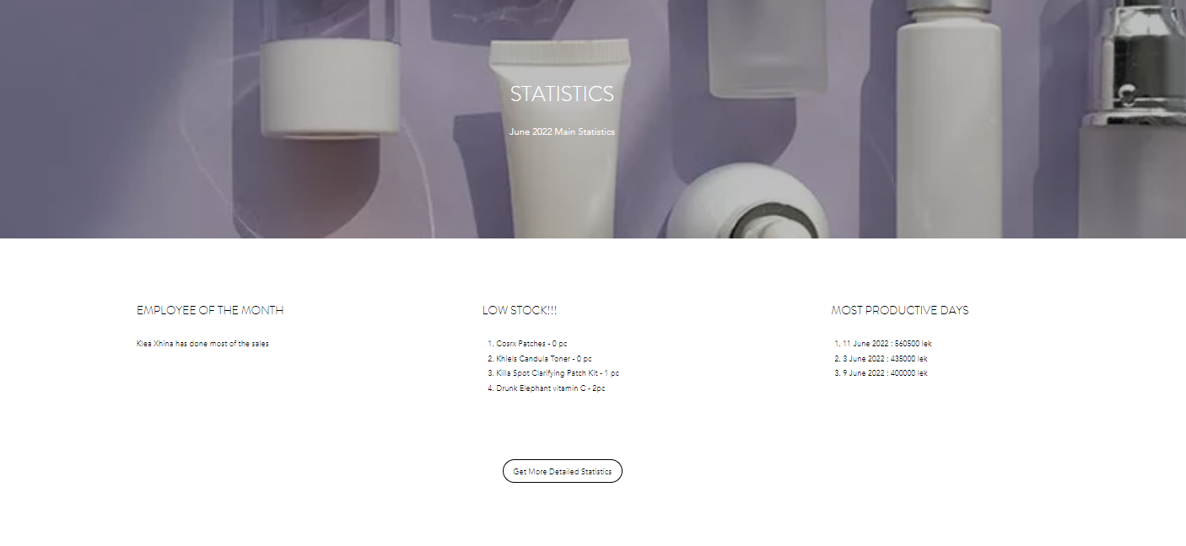

**Write a Message**

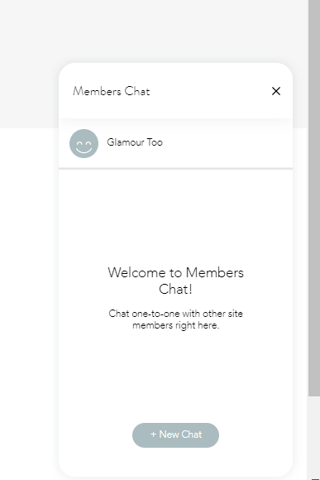

**LOGIN/REGISTER**

